Trade of Metal Fabrication
Module 4: | Structural Steel Fabrication
Unit 1: | Introduction to Structural Fabrication
 | Phase 2

Table of Contents
List of Figures 7
List of Tables 8
Document Release History 9
Module 4 – Structural Steel Fabrication 10
Unit 1 – Introduction to Structural Fabrication 10
Learning Outcome: 10
Key Learning Points: 10
Training Resources: 11
Key Learning Points Code: 11
Application of Pythagoras Theorem 12
Common Structure Sections 13
Locking and Retaining Devices 14
Slotted Nuts and Castle Nuts 15
Simmond’s Locknut 15
Spring Washers 16
Shakeproof Washers 16
Wire Locking 17
Tab Washers 18
Locking Plates 19
Taper Pins and Parallel Pins 20
Split Cotter Pins 22
Locking by Adhesives 22
Fasteners and Locking Devices 23
Types of Bolt 24
Black Bolt 24
Close Tolerance Bolt 24
Turned Barrel Bolt 24
Application and Advantages 27
Washers 28
General 28
Taper 28
Load Indicating Type “Coronet” 29
Spring Types 30
Flat Type 30
Black Marks and Cross Centres 32
Pitch Circle Diameter (P.C.D.) 33
Drifts 34
Nature of Force 35
Units of Length 37
Measurement of Length 37
Mechanical Properties of Materials 39
Behaviour of Materials under the Application of a Force 39
Material Removal 40
Principle of Moments 40
Clamping of Work 41
Use of Spanners 41
Moment of a Force 42
Principle of Moments 43
The Moment of a Force 44
Simple Atomic Structure 45
Basic Strength of Materials 46
Heat 47
Engineering Science 48
Fasteners used in the Industry 49
Structural Applications 49
Engineering Adhesives 50
Designing for Adhesives 51
The Bond Line 52
Engineering Applications 52
Instant Adhesives 54
Lifting and Turning Technology 55
Lifting Techniques 55
Kinetic Principles 55
Base Movement (8 Key Points) 55
Common Lifts 58
Forces and Levers 59
Clothing 61
Manual Handling of Loads Regulation 27 – 28 62
European Legislation 64
Material Removal 65
Movement of Materials under Adverse Conditions 65
Movement in the Workshop 65
Movement on Site 65
Structural Engineering 72
Appearance, Strength and Safety in Fabricated Structural Members 75
Appearance 75
Strength 75
Web Stiffeners 76
Bolted Joint 79
Theory 80
Thread Strength 81
Setting the Torque 81
Property Class 82
Failure Modes 82
Types of Bolts 83
Locking Mechanisms 83
See Also 84
External Links 84
References 84
Machine Tools 85
Introduction 85
The Off-Hand Grinding Machine 85
Types of Off-Hand Grinder 85
The Grinding Wheel 87
The Drilling Machine 89
Types of Drilling Machine 90
Torque Wrench 92
Beam Type 92
Click Type 93
Differences between Types 93
Ironworker 94
Structural Steel 95
Steel vs. Concrete 96
Fire Protection with Steel vs. Competition 96
Structural Steels 96
Common Structural Shapes 97
Standard Structural Steels 97
Carbon Steels 97
High Strength Low Alloy Steels 97
Corrosion Resistant High Strength Low Alloy Steels 97
Quenched and Tempered Alloy Steels 97
Using Machines 98
Lifting Objects 99
Self Assessment 100
Answers to Questions 1-5. Module 2.Unit 6 102
Index 105

List of Figures
Figure 1 - Right Angle Triangles 12
Figure 2 - Most Common Right Angle Triangle 12
Figure 3 - Steel Sections 13
Figure 4 - Bolts, Nut and Locknut 14
Figure 5 - Slotted and Castle Nuts 15
Figure 6 - Simmond's Locknut 15
Figure 7 - Spring Washer 16
Figure 8 - Types of Locking Washer 17
Figure 9 - Plan View of a Pressurised Cylinder 17
Figure 10 - Types of Tab Washer and Tab Washer Assembly 18
Figure 11 - Typical Locking Plate for a Hexagonal Nut 19
Figure 12 - Locking Terminals 20
Figure 13 - Operating Lever 21
Figure 14 - Taper Pin 21
Figure 15 - Proportions of Split Cotter Pins to BS 1574 22
Figure 16 - Keys and Keyways 23
Figure 17 - Fasteners and Locking Devices 23
Figure 18 - Correctly Bolted Joint 24
Figure 19 - High Strength Friction Grip Bolts 25
Figure 20 - Bolt Head 26
Figure 21 - Taper 28
Figure 22 - Load Indicating Type "Coronet" 29
Figure 23 - Spring Types 30
Figure 24 - Flat Type 30
Figure 25 - Nuts and Bolts 31
Figure 26 - Back Mark 32
Figure 27 - Cross Centre 32
Figure 28 - Pitch Circle Diameter (PCD) 33
Figure 29 - Splice Plate or Fish Plate 33
Figure 30 - Drifts 34
Figure 31 - Forces 35
Figure 32 - Vectors 36
Figure 33 - Frameworks 38
Figure 34 - Principle of Moments 40
Figure 35 - Clamping of Work 41
Figure 36 - Use of Spanners 41
Figure 37 - Tap Wrench 42
Figure 38 - Levers with Clockwise and Anticlockwise Force 43
Figure 39 - Structural Adhesive used to Bond Stiffener to Aluminium Car Bonnet 49
Figure 40 - Mild Steel Stiffeners Bonded to up and over Garage Door 49
Figure 41 - Loading Conditions 51
Figure 42 - Thread Locking 52
Figure 43 - Thread Sealing 53
Figure 44 - Retaining 53
Figure 45 - Instant Adhesives 54
Figure 46 - Base Movement 56
Figure 47 - Forces and Levers 60
Figure 48 - Symmetrical and Asymmetrical Inverted Disc Loading 61
Figure 49 - Welded Fabricated Beam 76
Figure 50 - Riveted or H.S.F.G. Bolted Beam 76
Figure 51 - Bolted Joint 79
Figure 52 - Bolted Joint Loads 80
Figure 53 - Types of Bolts 83
Figure 54 - Pedestal Grinder 86
Figure 55 - Bench Grinder 87
Figure 56 - Grinding Wheel Mounting 88
Figure 57 - Bench Drilling Machine 89
Figure 58 - Pillar Drilling Machine 90
Figure 59 - Drilling Operation in Progress 91
Figure 60 - Beam Type Torque Wrench 92
Figure 61 - Beam Type Torque Wrench Indicator 92
Figure 62 - Click Type Torque Wrench 93
Figure 63 - Ironworker 94
Figure 64 - Correct Posture for Lifting Objects 99

List of Tables
Table 1 - Property Classes 82

Document Release History
Date | Version | Comments
30/01/07 | First draft
13/12/13 | SOLAS transfer

Module 4 – Structural Steel Fabrication

Unit 1 – Introduction to Structural Fabrication
Duration – 7 Hours

Learning Outcome:
By the end of this unit each apprentice will be able to:
- Fabricate a bolted structural connection
- Read and interpret 1st and 3rd angle orthographic projection
- Identify material sections most common to structural fabrication
- Define the nature of force

Key Learning Points:
Sk | Measurement and marking/oxy/fuel cutting/drilling/assembly.
Rk | Identification of most common structure sections.
Sc Rk | Structural forms, their production and properties.
Sc Rk | Mechanical handling – safety precautions – lifting and turning techniques – lifting aids.
Sc Rk | Tools and machinery/spanners, drifts, dogs, torque spanner, drilling machines, angle grinders and attachments, steelworker machines, plate guillotine.
Sc Rk | Identification of different fasteners used in structural fabrication.
Rk | Structural fabrication uses in industry.
Sk Rk | Minimum pitch and edge distance.
Sc | Nature of force (Units of measurement – Force and Vectors).
H | Safety standards and precautions.
P | Standard and presentation of work.

Training Resources:
- Classroom and lecture facilities
- Standard fabrication workshop and equipment, safety clothing and equipment
- Drawing equipment, lectures and demonstrations
- Lecture notes and handouts, transparencies
- Technical manuals
- Materials as stated on drawings

Key Learning Points Code:
M = Maths D= Drawing RK = Related Knowledge Sc = Science
P = Personal Skills Sk = Skill H = Hazards

Application of Pythagoras Theorem
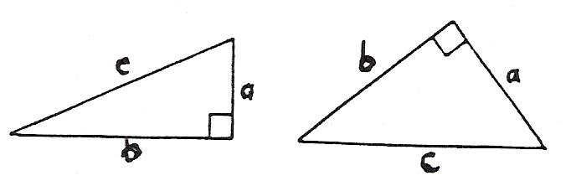
Figure 1 - Right Angle Triangles

In calculations involving right-angled triangles, Pythagoras's theorem is used. This can be given briefly with reference to the triangles in Figure 1(note that each has a right-angle):
C² = a² + b²

Where a, b and c are the lengths of the sides of the triangles, and c (the hypotenuse) is opposite the right-angle.

Figure 2 shows the most common right-angled triangle.

In Figure 2 the values 3, 4 and 5 have been divided by 10, multiplied by 2 and multiplied by 12 to give three other right-angled triangles.

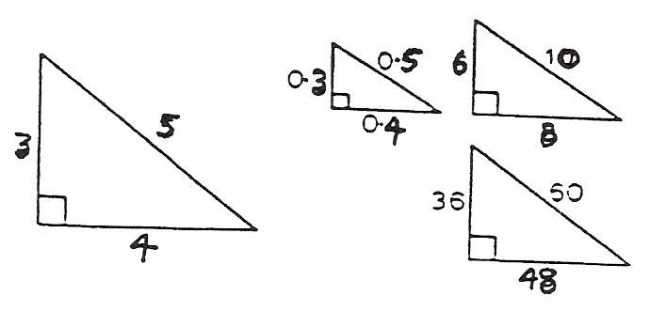
Figure 2 - Most Common Right Angle Triangle

Common Structure Sections

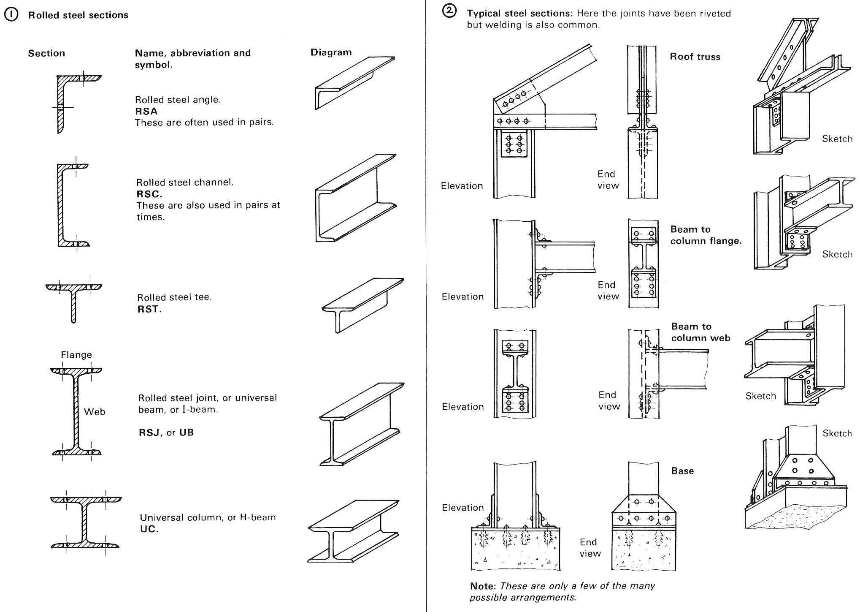
Figure 3 - Steel Sections

Locking and Retaining Devices
The function of a locking device is to prevent loosening or disengagement of mating components which may be operating under varying conditions of stress, temperature and vibration. The effectiveness of the locking device may be vital to safety.

One of the simplest locking devices is a locknut and these are generally thin plain nuts which are tightened against ordinary plain nuts or against components into which male threaded items are assembled. To ensure efficient locking, the bearing surfaces of the nut and component must bed together evenly and the correct degree of tightness obtained by applying the designed torque loading. The locknut should not be over-tightened as this may result in the stripping of the nut threads or overstressing of the male component. In cases where rotation can occur, the plain nut must be held stationary whilst the locknut is tightened.
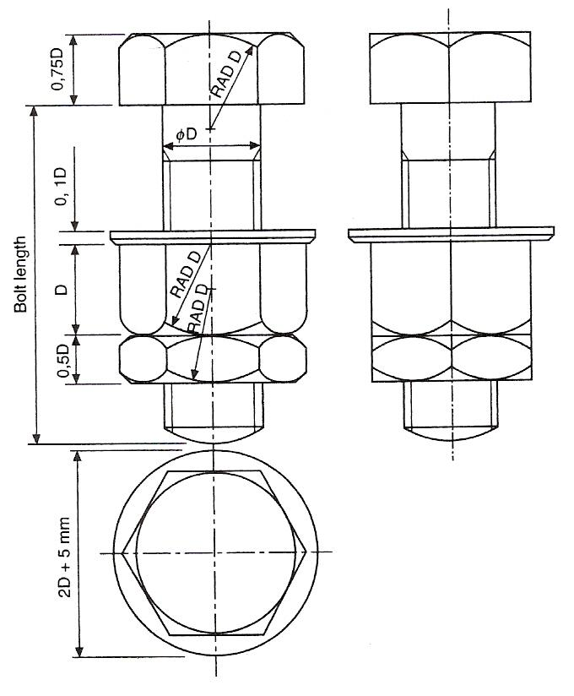
Figure 4 - Bolts, Nut and Locknut

Slotted Nuts and Castle Nuts
One method of preventing nuts from coming loose is to drill the bolt and use a pin through the assembly. Suitable nuts are shown in Figure 5. Slotted nuts are available for sizes M4 to M39 and have six slots. Castle nuts are also available with six slots between sizes M12 to M39 and eight slots between sizes M42 and M68. For convenience in drawing both types of nuts, the total thickness can be approximated to the thread diameter plus 2 millimetres.

Slotted nuts are reusable but difficult to apply where access is limited.

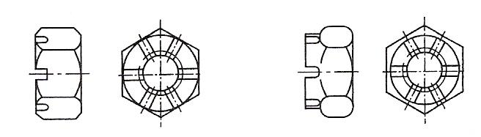
Figure 5 - Slotted and Castle Nuts

Simmond’s Locknut
This type of locknut incorporates a collar manufactured from nylon or fibre and the collar is slightly smaller in diameter than the internal thread diameter. The section in Figure 6 shows the collar in black. On assembly, the stud or bolt forces its way through the resilient collar which provides a frictional lock. The locknut is a little thicker than a conventional nut.

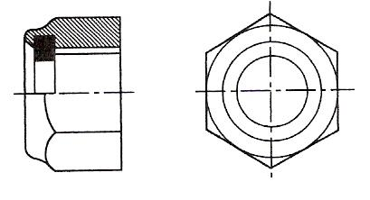
Figure 6 - Simmond's Locknut

Spring Washers
This type of washer is produced as a single or a double coil spring. The cross section is rectangular. Generally this type of washer dispenses with the simple plain washer although a plain washer can be used at the same time with assemblies where the component is manufactured from relatively soft light alloys. The free height of double coil washers before compression is normally about five times the thickness of the steel section.

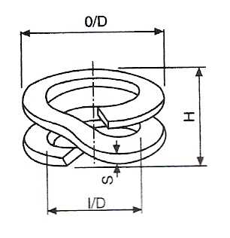
Figure 7 - Spring Washer

Shakeproof Washers
This type of washer is generally made from spring steel and serrations are formed on either the internal or external diameters. These serrations then bite into the pressure faces between the nut and the component when the nut is assembled. Some slight disfiguration of the component may result on assembly but this is of little significance except where anti-corrosion treatment of the component surface has previously been carried out. Some screws are pre-assembled with conical lockwashers which are free to rotate but do not come off.

Toothed lockwashers combat vibration and are especially suited to rough parts or surfaces.

Wire Locking
Non-corrodible steel and brass wire, of the appropriate gauge, are normally used for wire locking. Generally, a hole is provided for this purpose in the component to be locked and the wire is passed through and twisted. The lay of the wire between the anchorage and the component must always be such as to resist any tendency of the locked part or parts to become loose.
Figure 9 shows the plan view of a pressurised cylinder and the cover is held down by four bolts which are wire locked. The operation is performed with a single strand of wire. The wire is passed in sequence through the holes in the bolts and the ends are twisted together to tension the wire loop. Note that in order to become loose, the bolts must turn in an anticlockwise direction but this will have the effect of increasing the tension in the wire loop. The locking wire should only be used once.
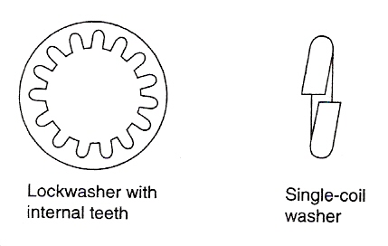
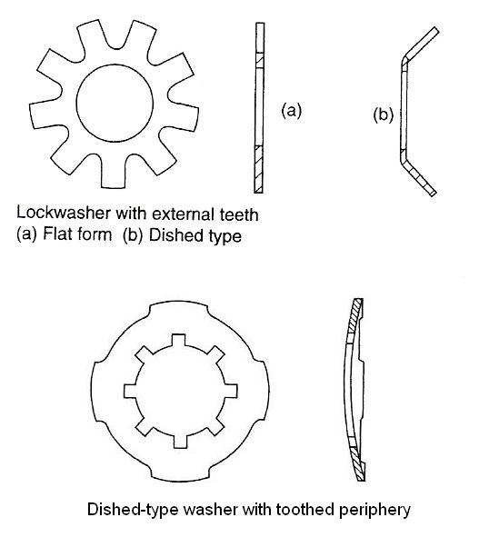
Figure 8 - Types of Locking Washer

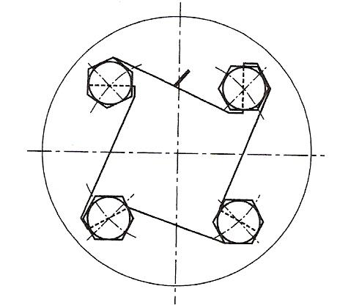
Figure 9 - Plan View of a Pressurised Cylinder

Tab Washers
Tab washers are thin metal washers designed with two or more tabs which project from the external diameter. On assembly, a tab is bent against the component or sometimes into a hole in the component. Other tabs are then bent up against the correctly tightened nut. Another pattern has a tab projecting from the inside diameter and this is intended to fit into a slot machined in the bolt, whilst the external tabs are again bent against the flat sides of the nut. The deformation of the tab washer is such that it is intended to be used only once.
Three different types of tab washer are shown in Figure 10 together with a typical assembly.
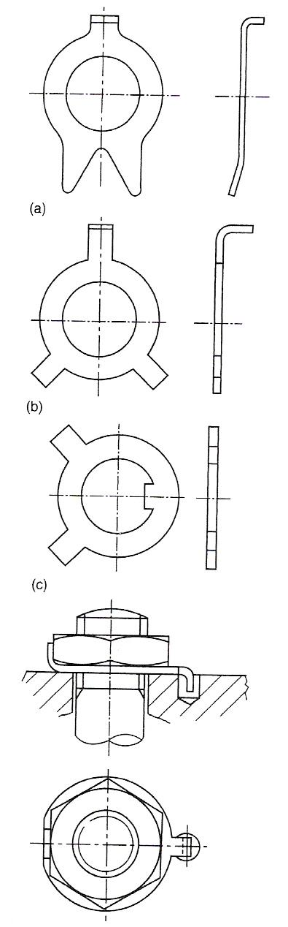
Figure 10 - Types of Tab Washer and Tab Washer Assembly

Locking Plates
Locking plates are manufactured usually from mild steel and fit over hexagonal nuts after these have been tightened on assembly. The locking plate is then secured on the component by a separate screw which may itself be fitted with a shakeproof or spring type of washer.

Locking plates may be used repeatedly, provided they remain a good fit, around the hexagon of the nut or the bolthead. Locking plates may be cranked, as in Figure 11 or flat.

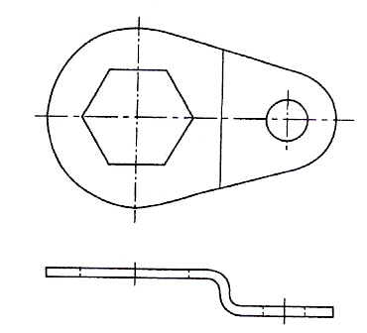
Figure 11 - Typical Locking Plate for a Hexagonal Nut

Figure 12 shows a selection of locking terminals where a 'Shakeproof' washer and a soldering lug are combined into one unit, thus saving assembly time. The locking teeth anchor the terminal to the base, to prevent shifting of the terminal in handling, while the twisted teeth produce a multiple bite which penetrates an oxidised or painted surface to ensure good conductivity. All three types of locking terminal are generally made from phosphor bronze with a hot-tinned finish.
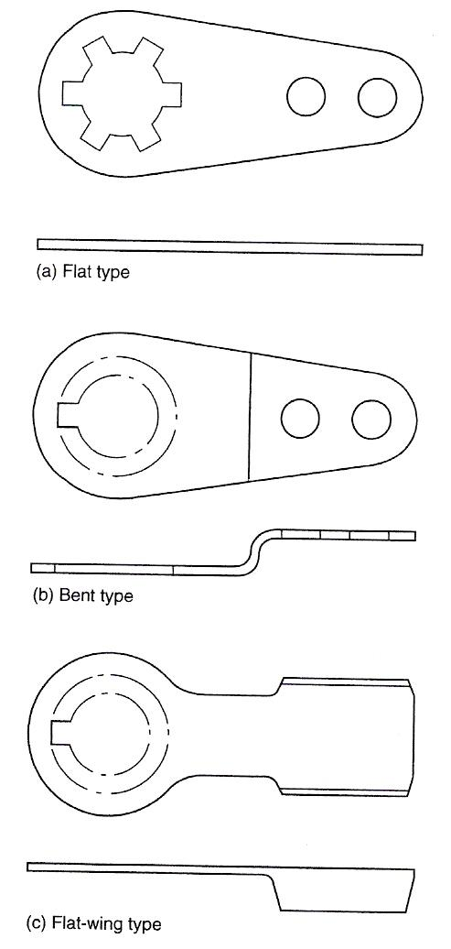
Figure 12 - Locking Terminals

Taper Pins and Parallel Pins
Taper pins, with a taper of 1 in 50, and parallel pins are used on both solid and tubular sections to secure, for example, levers to torque shafts and control rods to fork ends. Some taper pins are bifurcated, or split and the legs can be opened out for locking. Plain taper pins and parallel pins may also be locked by peening. To prevent slackness, these pins are assembled in accurate reamed holes. Undue force should not be used during the peening process or the security of the fittings may be impaired if the pin is bent.
Figure 13(a) shows part of a lever which is fixed to a hollow operating shaft by a bifurcated taper pin. On assembly, a hole is drilled which is slightly smaller than the diameter at the small end of the taper pin and this is enlarged by a taper pin reamer so that the small end of the taper pin, when pushed through the assembly, is flush with the surface. The pin is then driven into position. If the pin is of the bifurcated type, then the legs are spread to form an included angle of about 60°. Figure 13(b) shows the same operating lever assembled, but using a parallel pin, which has been peened over after ensuring that the component is adequately supported.

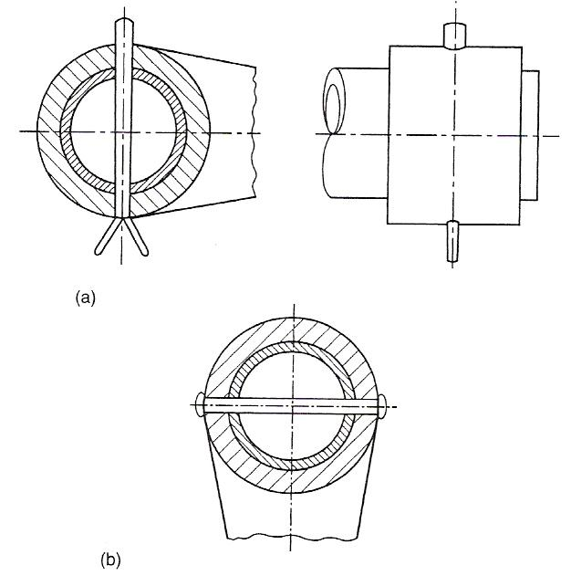
Figure 13 - Operating Lever

Figure 14 shows the general shape of a taper pin. Parallel sides are substituted for tapered sides in parallel pins.

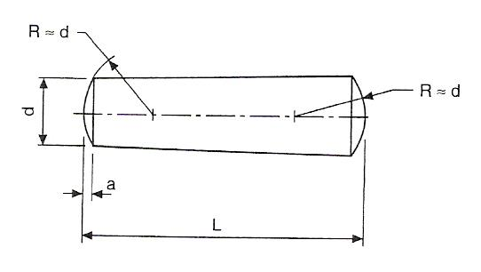
Figure 14 - Taper Pin

Split Cotter Pins
Ferrous and non ferrous split cotter pins are covered by BS 1574. The designating size of a split cotter pin is the size of the hole for which it is intended to fit. When reference is made to a split cotter pin in a parts list, this nominal dimension is followed by the length required. The closed legs of the shank of the pin form a circular cross section. The legs should be straight and parallel throughout their nominal length. Figure 16.32 shows alternative pins in detail.

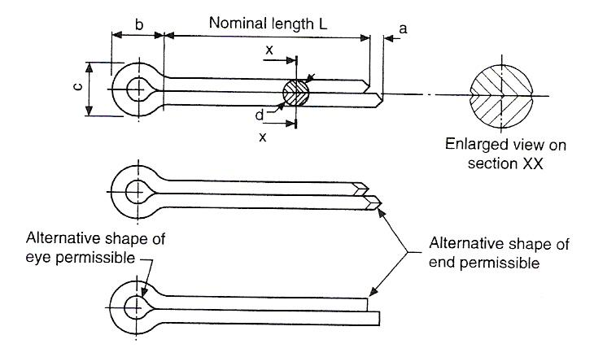
Figure 15 - Proportions of Split Cotter Pins to BS 1574

Many standard lengths are obtainable for each pin size and as a rough guide between 5 and 25 times the shank diameter.

Locking by Adhesives
Small components found in, for example, instruments and switches may be locked by the application of Shellac, Araldite, Loctite or similar materials. Shellac and Loctite are usually applied to the threads of nuts, bolts, screws and studs and the components are assembled while still wet. The parts should be free from grease to achieve maximum strength. Araldite is applied to the outside of the nut face and the protruding screw thread, after tightening. Araldite is an adhesive which hardens after mixing within a specified time period.

Fasteners and Locking Devices
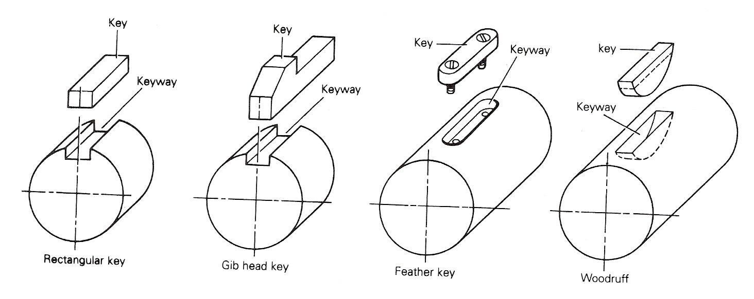
Figure 16 - Keys and Keyways

The term fastener is a name given to a number of devices used for holding component parts together. They include: bolts and nuts, screws (machine screws, set-screws and studs), rivets, keys and keyways, collars, clutches, soldering, brazing, and welding. Welding is a permanent method of fastening. Soldering and brazing can be classified as either permanent or temporary; the others are completely temporary methods of fastening. Figure 17 shows some of the commonly used fasteners. The same figure also shows various locking devices, which are used to prevent bolts, nuts and screws from working loose. Figure 16 shows various keys and keyways.
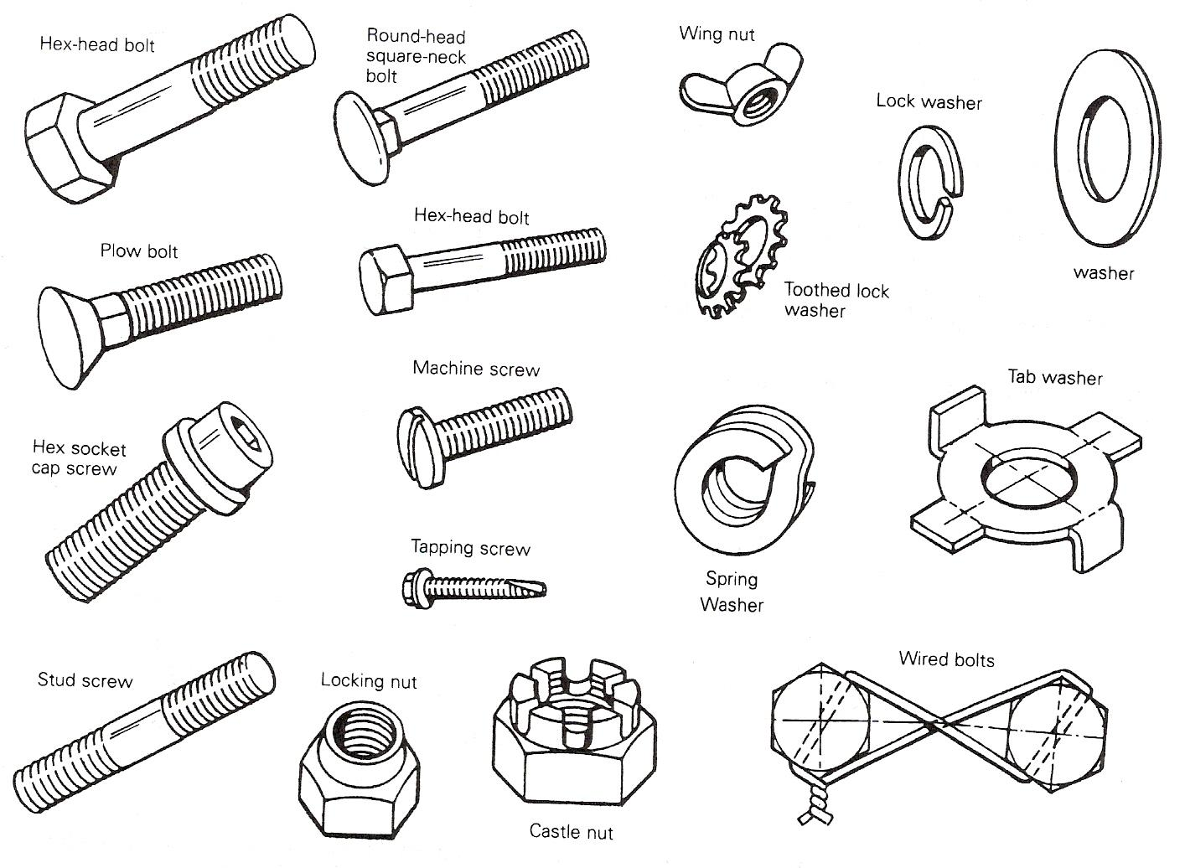
Figure 17 - Fasteners and Locking Devices

Types of Bolt

Black Bolt
Usually hot forged and roll or machine threaded. Used mainly as a service bolt, for temporarily bolting fabrications together prior to riveting and for tack bolting. They may also be used as permanent bolts for lightly stressed fabrications. They are the cheapest form of bolt available.
Clearance The diameter of the bolt hole is usually 1.5 mm larger than the nominal diameter of bolt shank (unthreaded portion).

Close Tolerance Bolt
These are bolts which have been machined under the head and on the shank to give a more accurate finish. They are used where compound members of several thicknesses require accurate alignment and where it is essential that no movement of the work must take place prior to riveting.
The clearance is as for Turned Barrel Bolts. Holes are finally reamed to correct size.

Turned Barrel Bolt
These bolts are fully machined with the diameter of the screwed portion of the bolt being 1.5 mm smaller than the diameter of the barrel, to prevent damage to the threads when fitting. The barrel length should bear fully on all parts connected with no thread in the hole (Figure 18). These bolts are used when the highest accuracy is required, and sub-assembly of fabrications prior to checking for alignment, and fabrications subject to heavy loads.
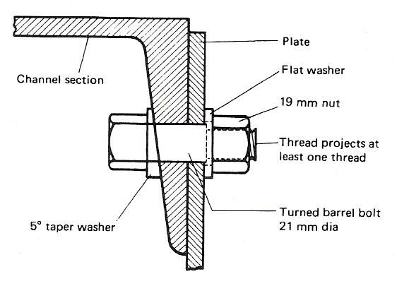
Figure 18 - Correctly Bolted Joint
Clearance Holes are drilled and reamed to a diameter equal to the nominal diameter of the barrel subject to a tolerance of +0.13 mm and -0 mm. (The bolt diameter is 0.13 mm smaller than the hole.)
High Strength Friction Grip Bolts (H.S.EG.) (BS 4395 and 4604)
There are several types of H.S.F.G. bolt (Figure 19), but all must be tightened to the specified minimum tension.

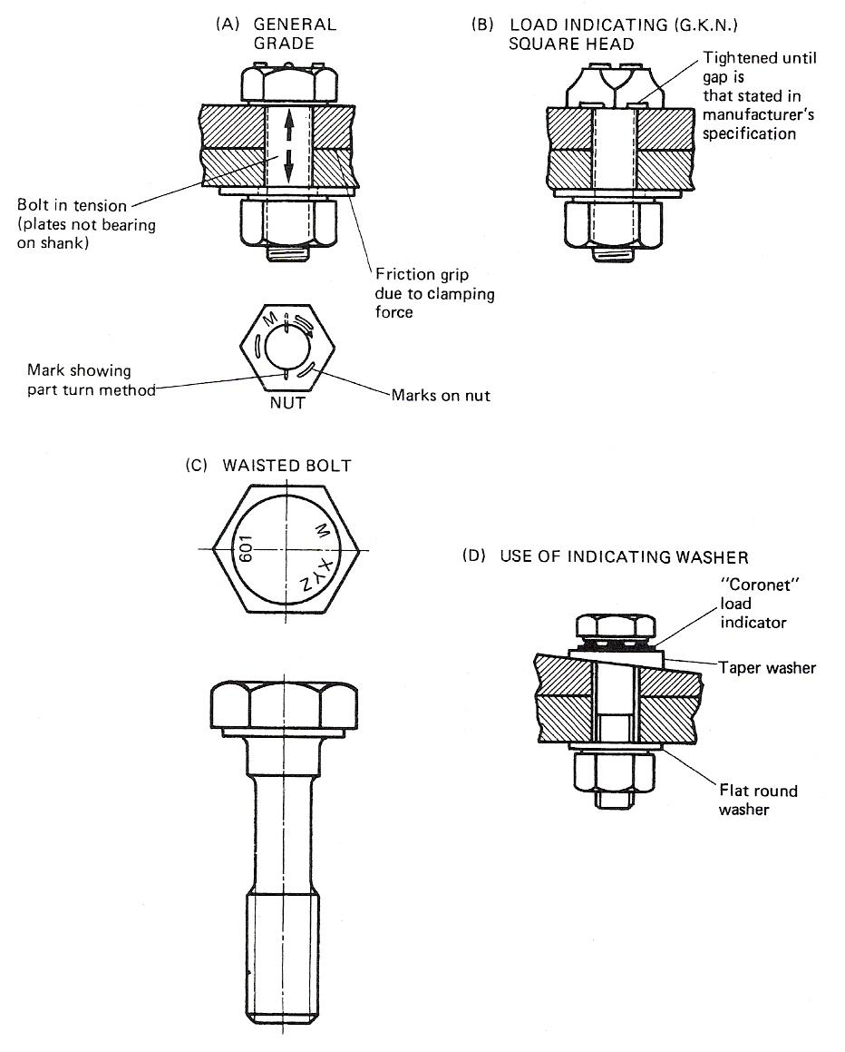
Figure 19 - High Strength Friction Grip Bolts
The term H.S.F.G. relates to bolts of high tensile steel, used in conjunction with high tensile steel nuts and hardened steel washers. They are tightened to a predetermined shank tension in order that the clamping force thus provided will transfer loads in the connecting members by friction between the parts and not by shear in, or bearing on, the bolts or plates of connecting members.

These bolts are made by a special cold working process which includes two operations: heading and thread rolling. Figure 20 shows the head for identification. Close tolerances ensure accuracy, and heat treatment is carried out afterwards.

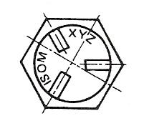
Figure 20 - Bolt Head

ISOM = ISO metric identification
XYZ = manufacturer’s (trade) marking
601 = strength grade (see Figure 19c)

The surfaces in contact must be free from paint, oil, dirt, loose rust and scale. Each bolt is assembled with one washer in cases where plane parallel surfaces are involved. The washer is placed under the bolt head or nut, whichever is to be rotated during the tightening operation. A tapered washer must be used also if the angle is above 3°.

Driving of bolts is not permitted.

If, after final tightening, a nut or bolt is slackened off, it must not be used again.

Higher grade (waisted shank) bolts BS 4604 may be used in joints subject to tension as well as shear, using the part turn method of tightening. Tightening by the torque control method is not permitted.

Application and Advantages
Used on road bridges, structural repairs and extensions, heavy installations subject to vibration, power station work and colliery winding gear.

H.S.F.G. bolts have virtually replaced hot driven rivets for fastening steel structures on site. They are also used to replace defective rivets on repair work.

Where structural members are shop assembled, welding is still more economical on the whole, but certain connections are better bolted and the difficulties encountered with site welding are eliminated when H.S.F.G. bolts are used.

System-built factories and offices are particularly suitable for H.S.F.G. bolts.

Compared with riveting, fewer H.S.F.G. bolts are needed than rivets for a given joint, and fewer men in the team needed to put them in, two against three or four. Less noise, simpler assembly (approximately three times faster than riveting), simpler inspection, and no fire risk. A smaller safety factor may be allowed than for riveted structures. On the whole, the cost is less using H.S.F.G. bolts.

Note: It is important that the torque on the nuts is correct for the bolt, so a pre-calibrated impact wrench is used, or the part turn method, or a feeler gauge if load indicating bolts or washers are being used. Bolts must be tightened in a definite sequence.

Clearance The diameter of the bolt hole is usually 1.6 mm larger than the nominal diameter bolt shank.

Washers

General
In all cases where the full bearing area of the bolt is to be developed, the bolt should be provided with a steel washer under the nut. This washer must be of sufficient thickness to avoid any threaded portion of the bolt being within the thickness of the parts bolted together and to prevent the nut, when screwed up, bearing on the shank of the bolt.

Taper
These washers should be placed under the nut or head of any bolt bearing on any bevelled surface. The angle of taper on the washer should match the angle of taper on the section. Washers are invariably marked with the angle of taper, i.e. 3°, 5° or 8°, or with the type of corner on H.S.F.G. taper washers (types B, C, D in Figure 21).

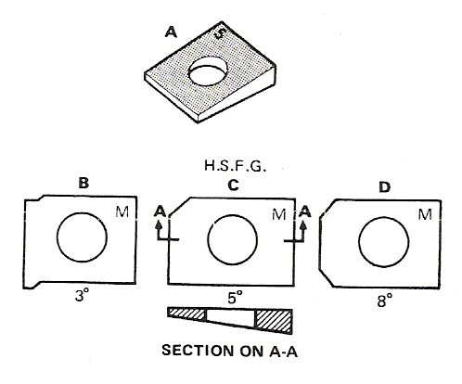
Figure 21 - Taper

Load Indicating Type “Coronet”
The "Coronet" Load Indicator is a specially hardened washer with protrusions on one face. The protrusions bear against the underside of the bolt head leaving a gap. As the bolt is tightened the protrusions are flattened and the gap reduced. At a specified average gap, measured by feeler gauge, the induced shank tension will not be less than the minimum required by Standards.

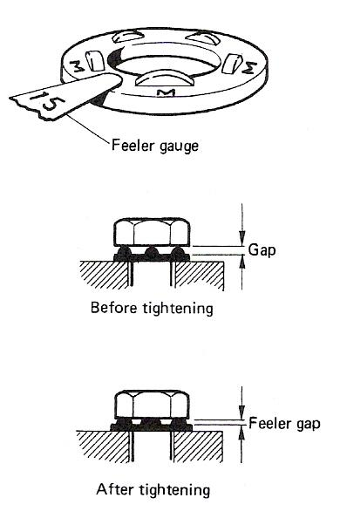
Figure 22 - Load Indicating Type "Coronet"

Spring Types
Where vibration is likely to be present to any degree in a fabrication, the nuts should be used with some form of spring washer to prevent the nut unscrewing during service.

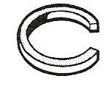
Figure 23 - Spring Types

Flat Type
Ordinary flat, low carbon steel washers are just punched into shape without further work but washers for turned barrel bolts are machined and should have a hole diameter not less than 1.6 mm larger than the barrel thickness and a thickness of not less than 3.2 mm so that the nut will not bear on the shoulder of the bolt. Flat wasters for H.S.F.G. bolts are made from low alloy steel and are extremely hard and may be distinguished by the three tabs on the outer edge (Figure 24).

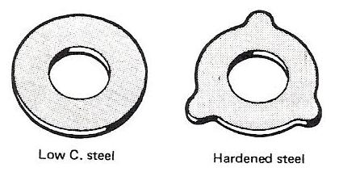
Figure 24 - Flat Type
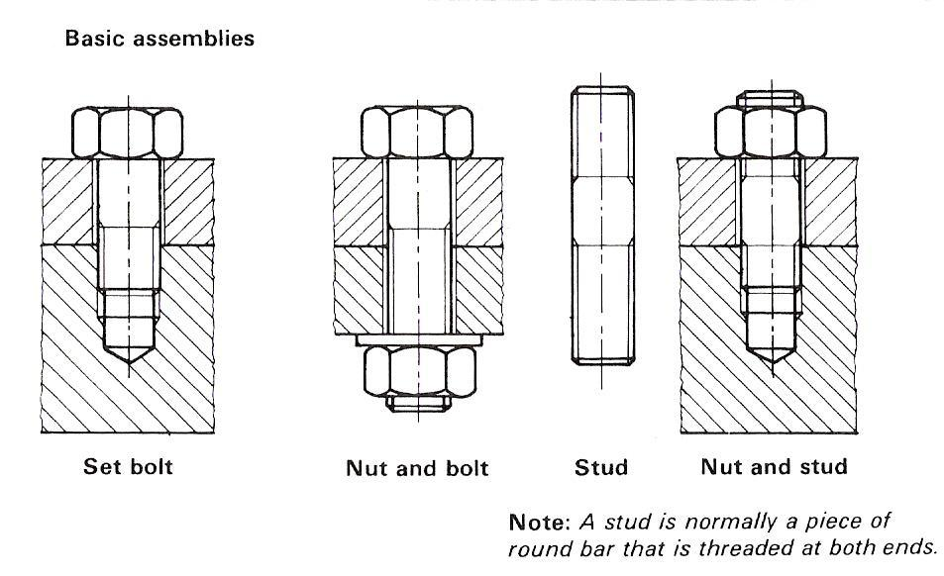
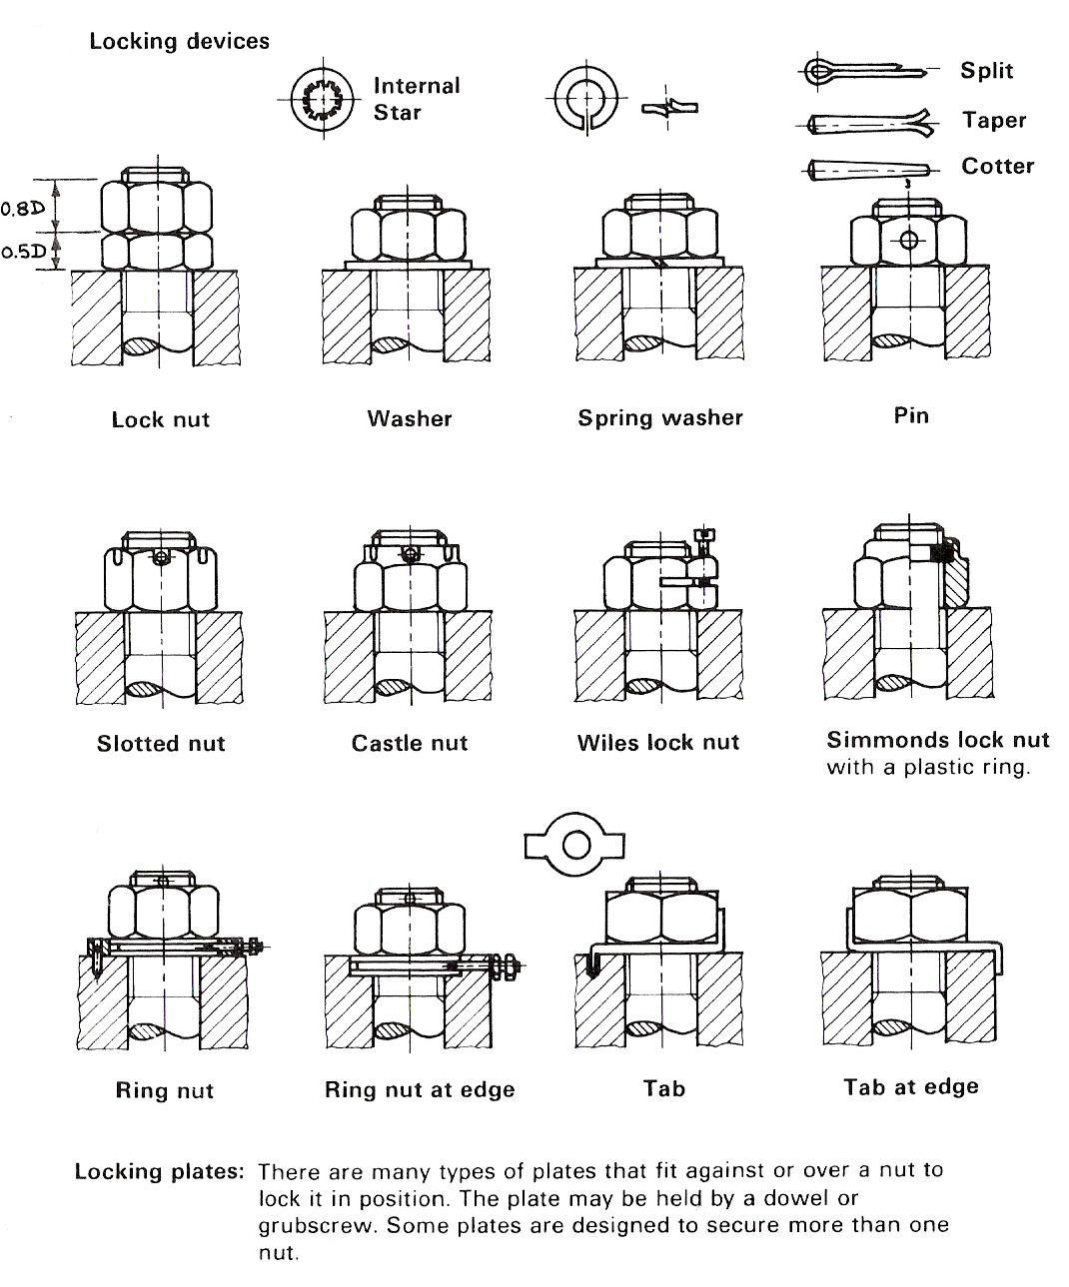
Figure 25 - Nuts and Bolts

Black Marks and Cross Centres
A ‘back mark’ is the distance from the heel of an angle or channel section to the centre of a hole in a flange.
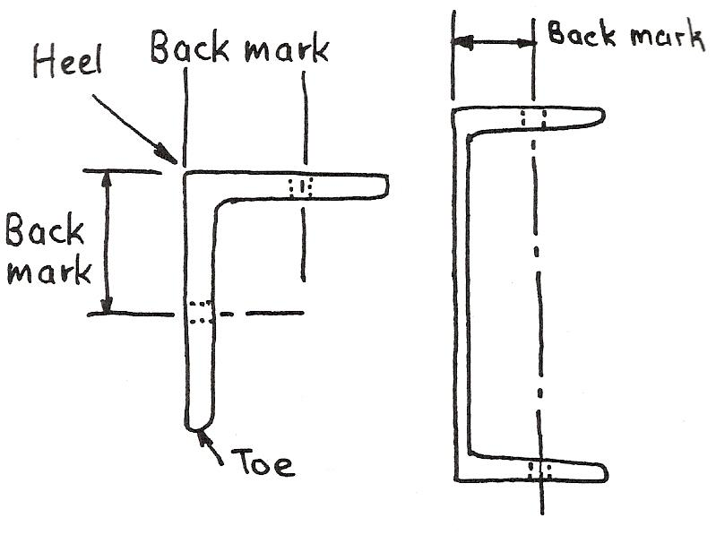
Figure 26 - Back Mark

A ‘cross centre’ is the distance between two holes in a flange of a universal column, beam, rolled steel joist or Tee section.
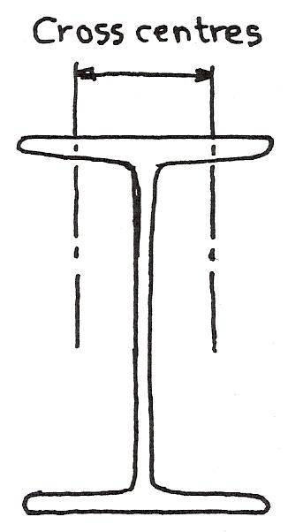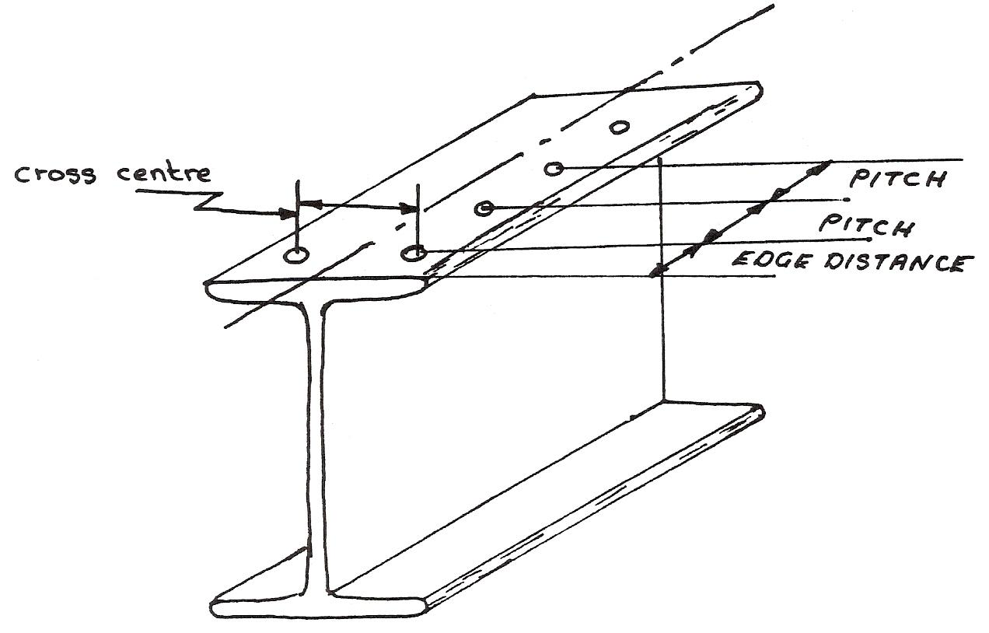
Figure 27 - Cross Centre

Pitch Circle Diameter (P.C.D.)
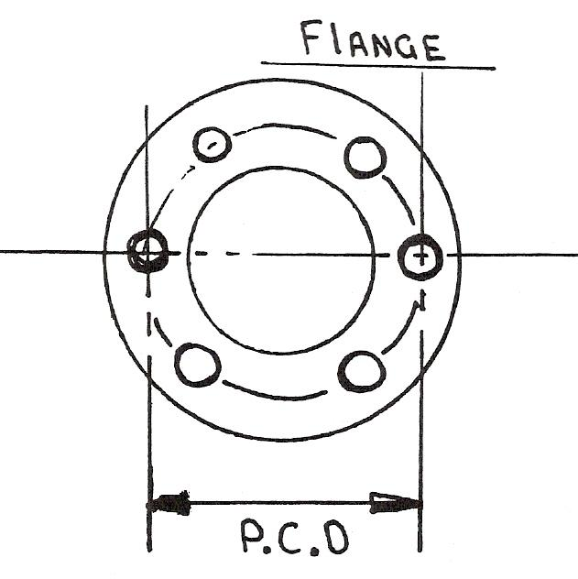
Figure 28 - Pitch Circle Diameter (PCD)

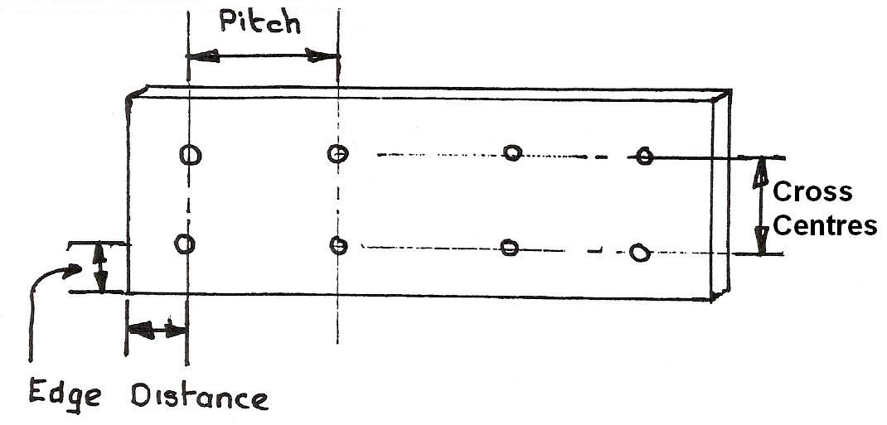
Figure 29 - Splice Plate or Fish Plate

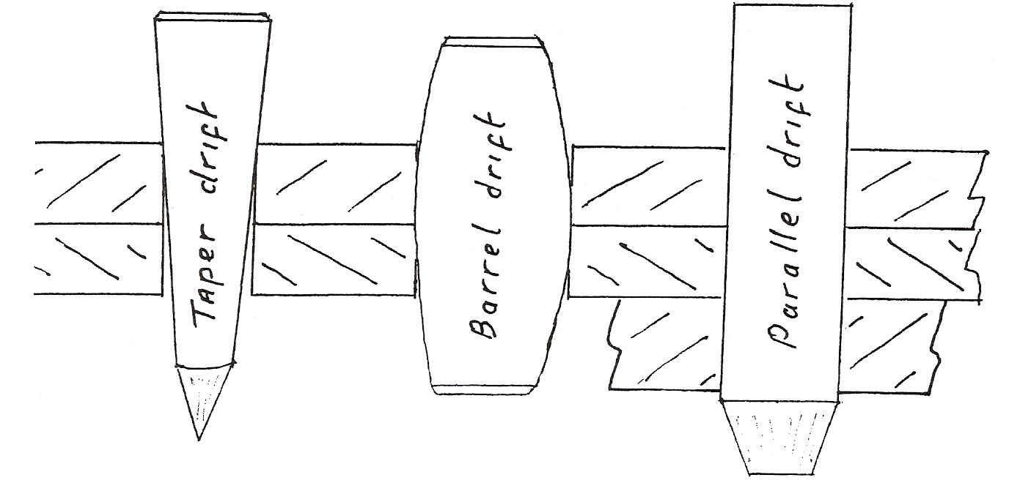
Figure 30 - Drifts

Drifts
Taper drift: used for ‘fairing’ or aligning holes. The plates move together to the correct position as the drift is hammered into the holes.

Barrel drift: used for ‘fairing’ or aligning holes in confined spaces. The drift is hammered until it passes through the holes.

Parallel drift: made approximately 0.75 mm less than the size of the hole, used to ‘fair’ or align solid drilled work. The work being reassembled after separating for cleaning – de-burring etc.

Nature of Force
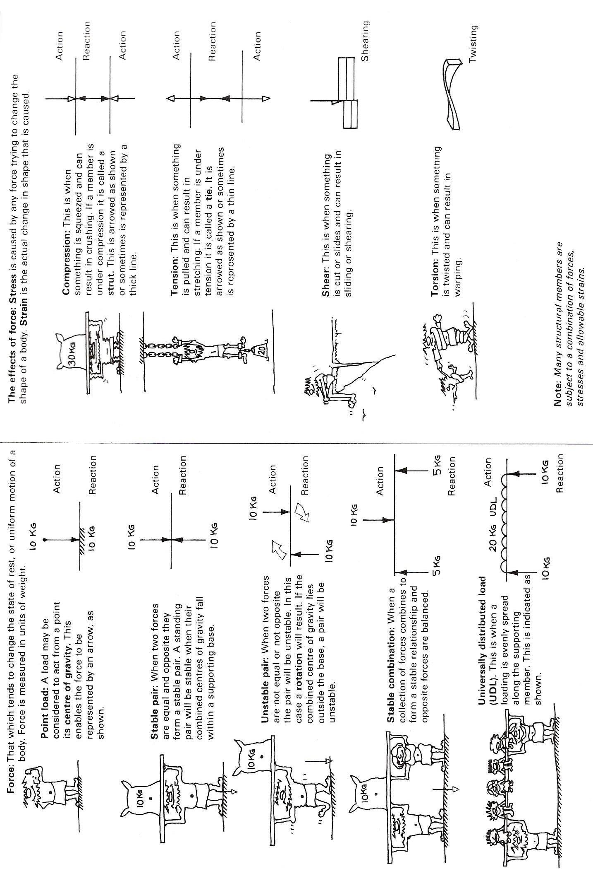
Figure 31 - Forces

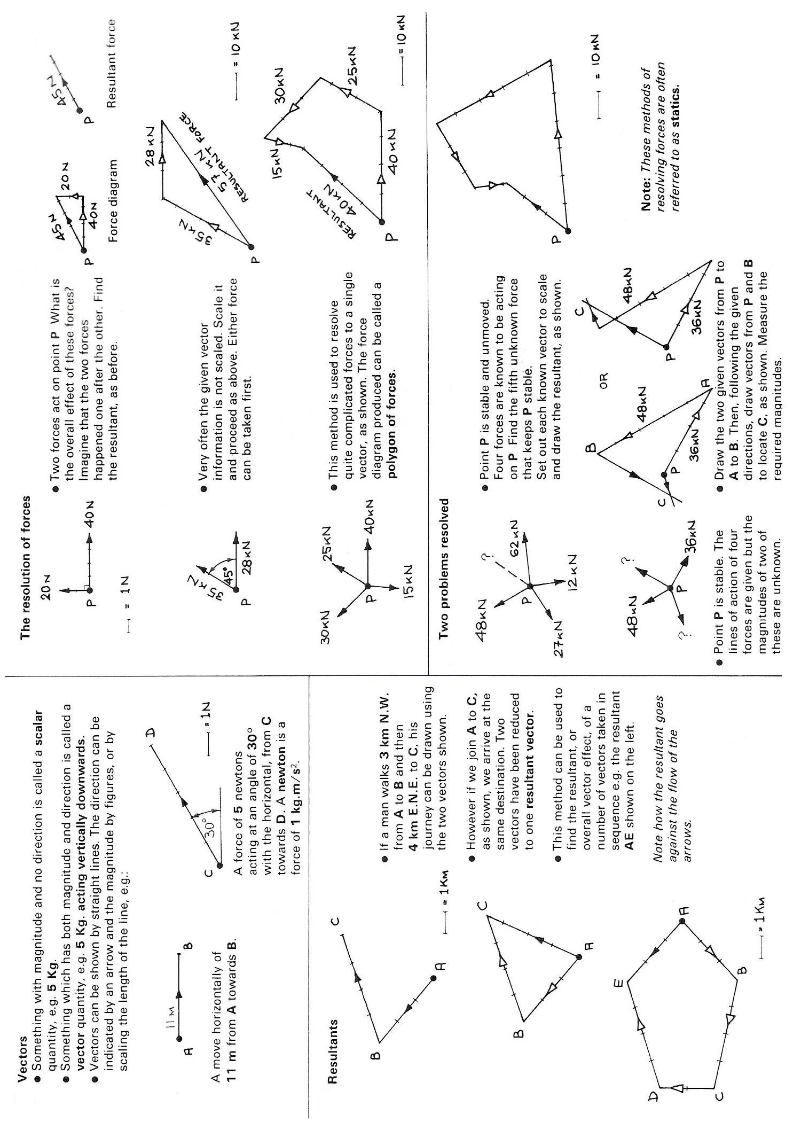
Figure 32 - Vectors

Units of Length
The international system of units, known as SI in every language, derives all its units from six basic units. These units are explained as they occur but the following summary may be useful at this stage.

QUANTITY
Length
Mass
Time
Force

NAME OF UNIT
Metre
Kilogramme
Second
Newton

UNIT SYMBOL
m
kg
s
N

Measurement of Length
The basic unit of length is the metre (m), for convenience the metre is multiplied and divided by multiples of 10 to/from larger and smaller units.
To get a feel for the size of the metre, the height of the ceiling in a room is typically 2.4m. The electrical light switch is usually situated about 1.5m above floor level.
For small units of length the millimetre (mm) is used. There are 1000 millimetres (mm) in 1 metre. To get an idea of its size, the millimetre (mm) is about the thickness of a hacksaw blade. The diagram below will help you to see the relationship of these units.
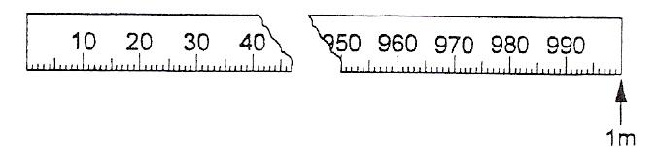
The kilometre (km) is used to measure long distance.
1 Kilometre = 1000 metres (m)
To convert units of measurement within the metric system, all we have to do is multiply or divide by the appropriate power of 10.

Example 1
2.25m = 2250mm
Multiply by 1000 when converting from metres to millimetres. Move the decimal point three places to the right.
85km = 85000m (Multiply by 1000)

Example 2
5750mm = 5.75m
Divide by 1000 when converting from millimetres (mm) to metres (m). Move the decimal point three places to the left.
75000m = 75km (Divide by 1000)

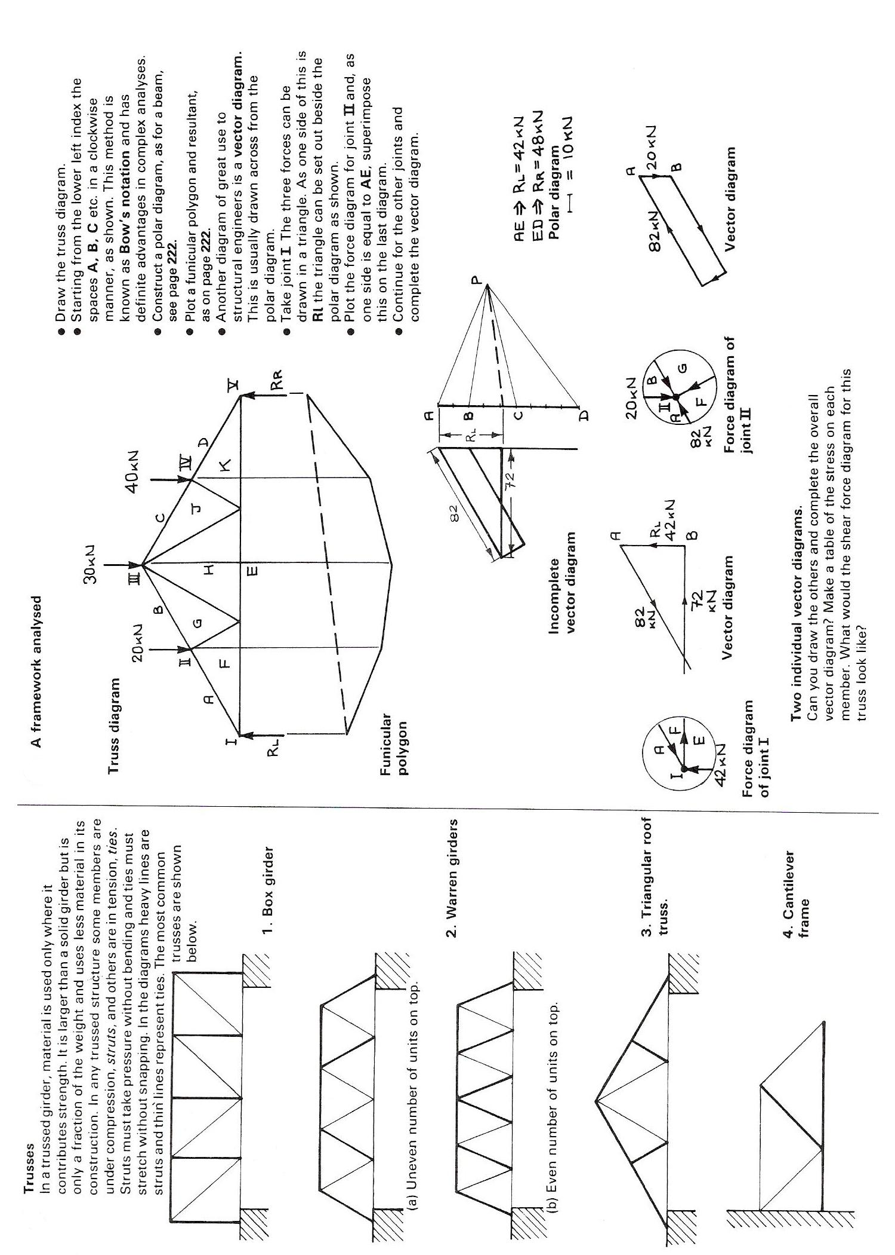
Figure 33 - Frameworks

Mechanical Properties of Materials

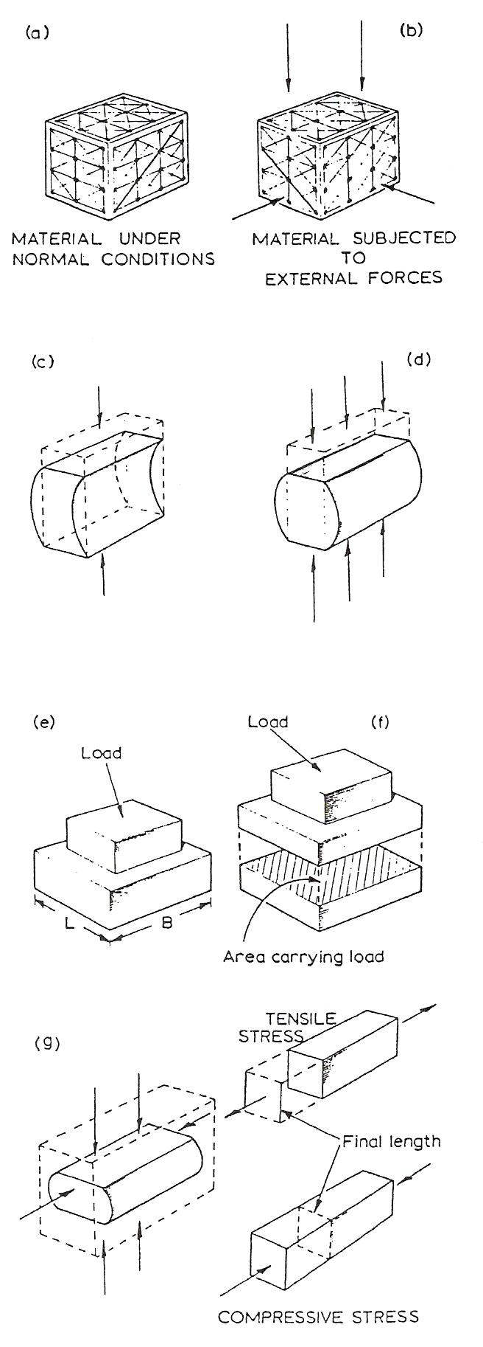
Behaviour of Materials under the Application of a Force
- Solid materials are made up of regular arrays of atoms as in pure metals, or large molecules as in plastics and rubbers. The atoms or molecules remain in set patterns, unless acted upon by some outside influence or force.
- When the material is subjected to some external influence or force, the atoms or molecules set up a resistance against any change in pattern.
- If you take a pencil rubber and squeeze it between your finger and thumb the rubber bends and buckles, as shown in the sketch. When the pressure is released the rubber returns to its normal shape.
- All solids behave in a similar manner in that they will buckle and bend, swell and stretch, but not with the same startling results as a pencil rubber. Metals, like rubber, will return to normal when the force is removed unless they have been sufficiently overloaded to exceed the elastic limit of the material.
- A force acting on a material will therefore produce a resistance or an internal reaction inside the material. This reaction tries to resist any change in dimension caused by the influence of the force.
This internal reaction is called a stress.
- Each load or force rests or acts upon an area of material. If we divide the load by the area carrying the load then
Load/Area will give a ratio called the stress
i.e. Stress = Load/Area
- Like rubber, metals and other materials will change shape under the influence of a stress: they will stretch and compress. Therefore if a material is observed to be lengthening or shortening or changing its dimension, that material is under the influence of a stress. The changing of the dimensions of a body is called straining of the material. Where there is stress in a body there is always an accompanying strain.

Material Removal

Principle of Moments
A crowbar is shown here being used to raise a heavy object. A force of 200 N is applied to the handle. We can prove by calculation that a much larger force is applied at point 'X'.
Note that the fulcrum point of the crowbar rests on the ground.
Using the principle of moments
Clockwise moments = 200 N x 0.8 m
= 160 Nm.
Anticlockwise moments = FN x 0.1 m
As clockwise moments = anticlockwise moments
160 = F x 0.l
:. 160/0.1 = F
:. 1600N = F

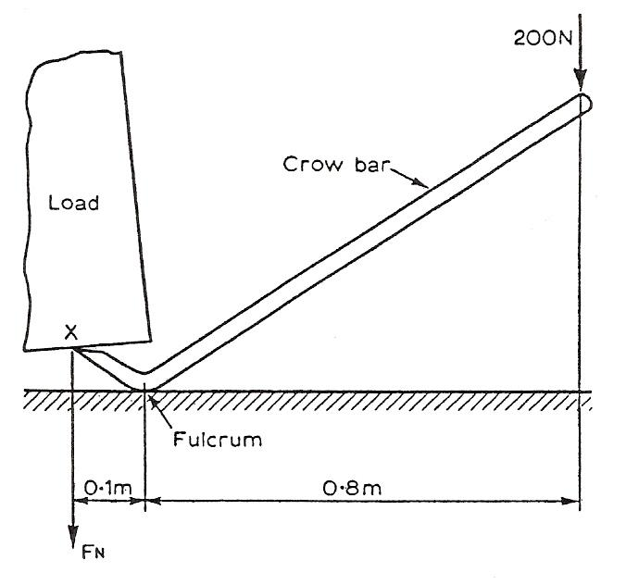
Figure 34 - Principle of Moments

Clamping of Work
Work must be clamped securely before machining. Using the principle of moments,
Clockwise moments = FN x 0.01 m
Anticlockwise moments = 60 N x 0.05 m
= 3 Nm.
:. F x 0.0l = 3
F = 3/0.01
F = 300 N

We can see from the above calculation that as the work is nearer the fulcrum the greater the force required for equilibrium.
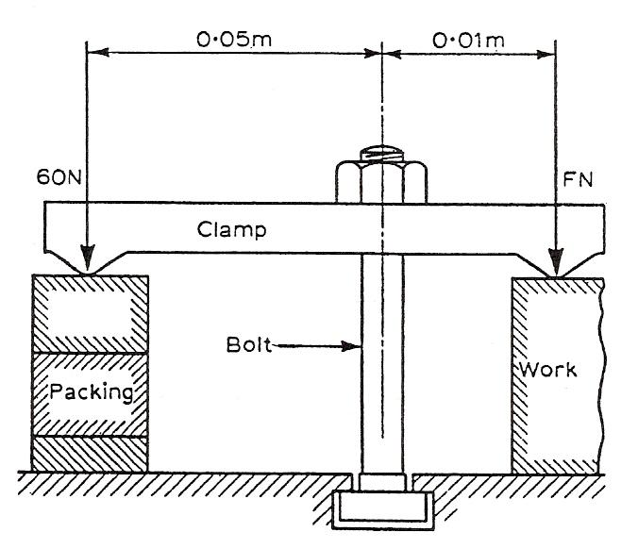
Figure 35 - Clamping of Work

Use of Spanners
Very often maximum tightening forces are specified for bolts and studs. A torque wrench (opposite) can be used to prevent over-tightening.
The sleeve of the torque wrench can be rotated and set to graduations on the body of the wrench. At the required torque a ratchet slips preventing over-tightening and possible straining of the bolt or stud.
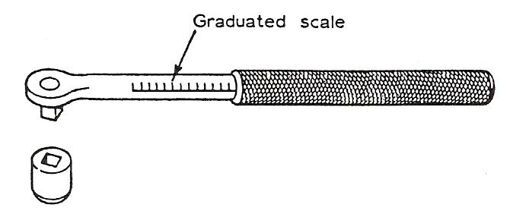
Figure 36 - Use of Spanners

Moment of a Force
Consider now the forces applied to a tap wrench. It can be seen that the fulcrum is now in the centre with the same force applied to each handle.

Total turning moments = (30 x 0.2) + (30 x 0.2)
= 6.0 + 6.0
= 12 Nm.

Both forces are clockwise about the fulcrum so the total turning moment is clockwise.

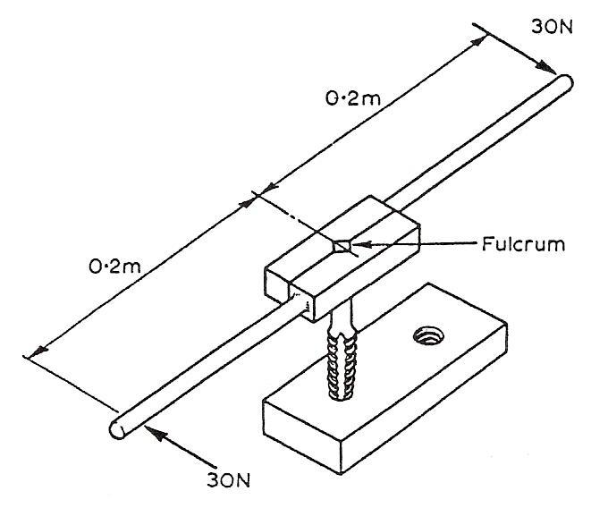
Figure 37 - Tap Wrench

Principle of Moments
If we refer to the diagram below, a lever is shown with a clockwise force of 30 N and an anticlockwise force of 30 N. The distance between the fulcrum and each force is equal. The lever will therefore balance. Because,
c.w. moment = anti c.w. moment
30 x 0.2 = 30 x 0.2
Consider now the lever shown here. It can be seen that if the fulcrum is moved to one end a greater force is required to maintain a state of balance, i.e.
c.w. moment = anti c.w. moment
30 x 0.3 = 90 x 0.1
or 9 Nm = 9 Nm.
The principle of moments is that for balance or equilibrium:
The sum of the clockwise moments must equal the sum of the anticlockwise moments.
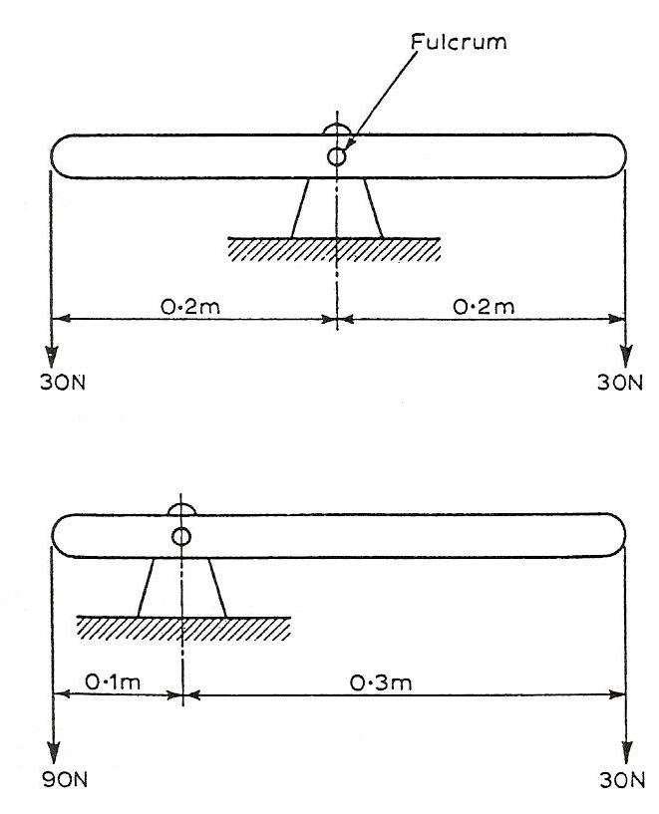
Figure 38 - Levers with Clockwise and Anticlockwise Force

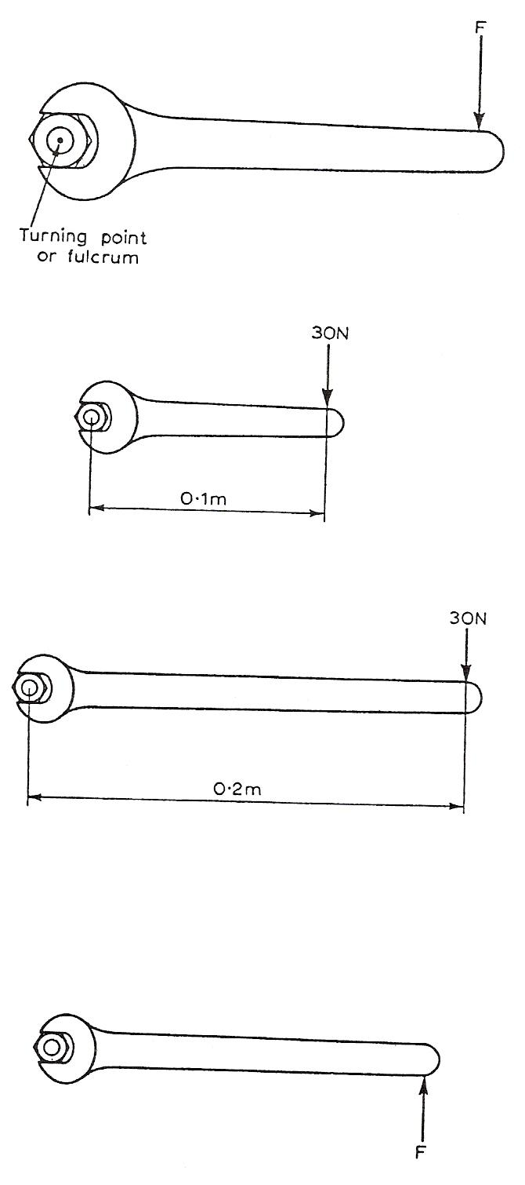
The Moment of a Force
The top diagram shows a force F applied to a spanner. The spanner rotates about a point in the centre of the nut. This force has had a turning effect on the spanner. The turning effect is called a moment and the turning point is called the fulcrum.

The moment of a force is measured by multiplying the force and its distance from the fulcrum.

Consider now the spanner opposite.
The force = 30 N (N = Newtons)
The length = 0.1 m (m = metres)
:. 30 N x 0.1 m = 3.0 Nm.

Now if we apply the same force to a spanner twice the length,
Force = 30 N
Length = 0.2 m
:. 30 N x 0.2 m = 6.0 Nm.

It can be seen that the same force applied to the longer spanner results in more force applied to the hut.

The turning moments we have considered so far have taken place in a clockwise direction so these may be called clockwise moments.

The bottom diagram shows a force applied to a spanner in an anticlockwise direction. This causes an anticlockwise moment.

Simple Atomic Structure
Moment of a Force: The moment of a force is its turning effect and is measured by the product of the force and its perpendicular distance from the point to its line of action.
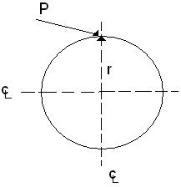
Units: Nm, Nmm, kNm

Torque: Torque is a turning moment.
Torque = P x r
Units: Nm, Nmm
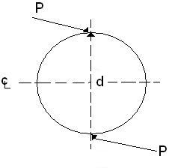
Couple: When two equal and opposite forces act on a body they are said to form a couple. The moment of a couple is one of the forces multiplied by the distance between them.
A COUPLE CAN ONLY BE BALANCED BY ANOTHER COUPLE.
Moment = P.d

Principle of Moments: When a number of co-planer forces keep a body in equilibrium the sum of the clockwise moments about any point in the place is equal to the sum of the anticlockwise moments about the same point.

Centre of Gravity: The C.G. of a body is the point in the body where the whole weight of a body appears to act. The C.G. of a triangle is ⅓ the perpendicular height from the base and the C.G. of a cone or pyramid is ¼ the perpendicular height from the base.

Pressure: May be expressed as force per unit area.
Units: N/m² or kN/m²
The pressure at a point in a liquid or fluid depends on the depth and the density.
Pressure = hpg

Energy: This is the ability to do work or the source from which work can be obtained.

Potential Energy: This is the energy possessed by a body by virtue of its position.

Kinetic Energy: This is the energy due to the motion of a body.
K.E. = mv²/2 Joules, where m = Kgs and v = m/s
Law of Conservation of Energy: The principle of conservative of energy states that energy can neither be created nor destroyed, but is convertible from one form to another.

Friction: Friction is resistance to relative motion between two bodies in contact. Friction always opposes motion. Friction depends upon:

- condition of surfaces,
- normal reaction, and
- nature of the materials.

Basic Strength of Materials
When a gradually increasing load is applied to a suspended wire it progressively stretches until it eventually breaks. Beyond a certain point the material takes a permanent set and does not fully recover and this point is called “the elastic limit”. Hookes law states that stress is proportional to strain within the elastic limit.

Stress is force per unit area.
or
Stress = Load/Cross Sectional Area

Units: N/m², N/mm², kN/mm²

Strain = Change in Length/Original Length (no units)

Youngs modulus (E) is a measure of the stiffness of a material.

E = Stress/Strain = Force/Unit Area
Change in Length/Original Length
Units: N/m²

Some common Densities g/cm³:

Aluminium
Copper
Gold
2.7
8.9
19.3
Silver
Zinc
Mercury
10.5
7.1
13.6

Heat
Heat is a form of energy. Temperature is the degree of hotness or coolness of a body.

A thermometer is an instrument for measuring temperature.

Upper fixed point = 100°C

Lower fixed point = 0°C

Temperature of human body = 37°C

Temperature of furnaces measured with a pyrometer.

Melting Temps for Common Metals

Aluminium
Copper
Lead
Tin
Zinc
Solder
660°C
1083°C
327°C
232°C
419°C
180°C
Silver
Gold
Brass
Cast Iron
Wrought Iron
Steel
1230°C
1340°C
930°C
1175°C
1530°C
1450°C

A thermostat is a device for maintaining a constant temperature.

The coefficient of linear expansion of a metal is the amount by which unit length of the metal expands for each unit degree of temperature it is heated.

Specific Heat Capacity: The specific heat capacity of a substance is the amount of heat required to change the temperature of 1kg of the substance through 1°C.

Units: kJ/kg°C (for water it is 4.2 kJ/kg°C).

Engineering Science
Definitions, Units and Formulae.

Mass: The quantity of matter in a body.
Units: gram (g), the SI unit is the Kg.

Weight: The force with which a body is attracted towards the centre of the earth.
Units: Newton (N) and the Kilonewton (KN).

Force: Force may be defined as that which changes or tends to change the state of rest of a body or its uniform motion in a straight line.
Units: N, KN.

Newton: A Newton is that force which gives a mass of 1kg an acceleration of 1m/s².

Resultant Force: The resultant of a number of forces acting together is the one force which would have exactly the same effect as the combined actions of the given forces.

The Equilibrant: The equilibrant of a number of forces acting together is that one additional force that would produce equilibrium.

Parallelogram of Forces Law: If two forces acting at a point are represented in magnitude and direction by adjacent sides of a parallelogram, the resultant of these two forces will be represented by the diagonal of the parallelogram between the two sides.

Triangle of Forces Law: If three co-planer forces (i.e. three forces acting in the same plane) are in equilibrium then they may be represented in magnitude and direction.

Fasteners used in the Industry

Structural Applications
Structural adhesives are ideal for bonding large areas of sheet materials. They can produce a much better finished appearance to an assembly then, say, rivets or spot welding or screws. The local stress introduced at each fixing point will be eliminated. Furthermore, adhesives prevent the corrosion problems normally associated with joining dissimilar materials. This is a cost effective method of providing high strength joints.
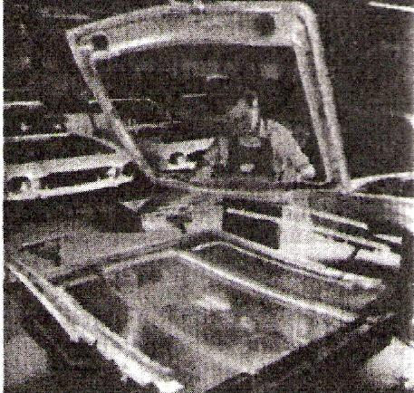
Figure 39 - Structural Adhesive used to Bond Stiffener to Aluminium Car Bonnet
To line up the two parts a purpose made fixture is designed.

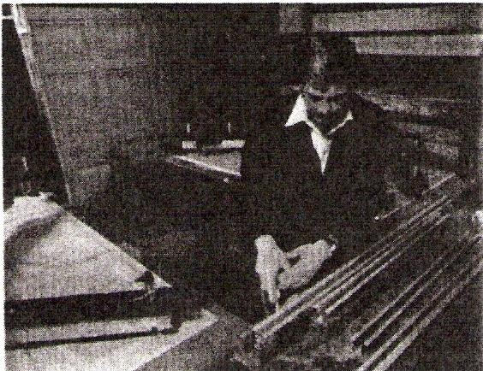
Figure 40 - Mild Steel Stiffeners Bonded to up and over Garage Door
Result: rigidity, unblemished exterior surfaces.

Engineering Adhesives
The use of adhesives is now a well established practice in manufacturing. New materials and production processes have considerably increased the options available to the engineering designer. Adhesive bonding is a proved cost effective manufacturing method and can be used with confidence. A basic principle is however that joints should be designed with this method of production in mind when the product is in the early stages of development.

The following are some advantages of using adhesives:

- Stress concentrations present in bolted, riveted or spot welded joints are avoided.
- The distribution of stresses achieved by adhesive bonding permits a reduction in weight and cost. Especially relevant with fragile materials and lightweight structures. Joint strength and fatigue properties are improved.
- Production costs are reduced due to the elimination of drilled holes and other machining operations. Labour costs are reduced with automated assembly work.
- Structures are generally stiffer despite weight reduction since the bonding covers the whole area of the join. Rivets, screws and spot welds pin the surfaces together only at localised points. Loading may be increased before buckling occurs.
- Gap filling properties. Certain adhesives are gap filling, and this makes possible the continuous joining of materials where the gap along the joint is of irregular width.
- Delicate or brittle materials such as metal foils or ceramics are readily bonded.
- High strength bonds can be formed at room temperature with minimal pressure by using cold-setting adhesives.
- The film formed by the adhesive resists corrosion, can form a leak-proof seal and insulate dissimilar metals against electrochemical action.

Designing for Adhesives
For the best possible performance, joints should be specifically designed for adhesive bonding. Follow this principle and much better joints will be achieved than if bonding is adopted as a substitute for welding in a joint designed for that purpose. Bond stresses, materials, type of adhesive, surface preparations, method of application and production requirements can then all be considered in relation to each other at the outset. The designer should consider especially the effect of shear, tension, cleavage and peel stresses upon the joint. Bonded joints perform best under conditions of tension (pure), compression or shear loading; less well under cleavage; and relatively poorly under peel loading. The loading conditions are shown in Figure 41.
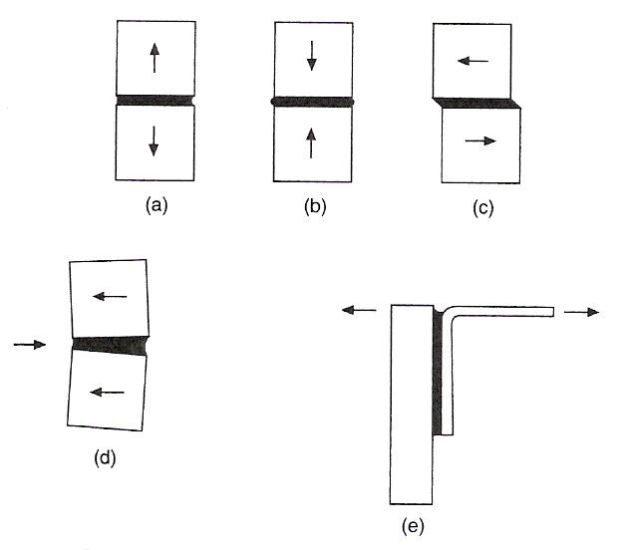
Figure 41 - Loading Conditions
a) Tension b) Compression c) Shear d) Cleavage e) Peel

Designing a joint to take pure tensile or compressive stresses is normally impracticable with sheet materials, so all joints in sheet materials should be designed so that the main loading is in shear. Joints between massive parts perform well in tension or compression loading, provided this is uniform - a side load may set up excessive cleavage stresses in a tension-loaded bond. (Figure 41(d)). Cleavage loading will concentrate stress at one side of the joint. Bond area may have to be increased to withstand this load so the joint will not prove so economical in terms of material and/or adhesives as joints designed for shear and tension stresses. Peel strength is usually the weakest property of a joint. A wide joint will be necessary to withstand peel stresses, plus the use of an adhesive with high peel strength.
For an adhesive to be used, a joint must allow the easy application of the adhesive, must allow for the adhesive to cure fully, and must be designed to give uniform stress. Even in a simple face-to-face joint it must be possible to apply adhesive to one surface and for it to remain there until the two parts are brought together and after that until curing takes place.
These requirements highlight the need for a choice of thin, thick or thixotropic adhesives. Design details which may also be significant include removal of sharp edges and substitution of a bevel or radius.

The Bond Line
The gap between the parts, and therefore the thickness of the adhesive film, has an important bearing on the characteristics of the joint. In terms of simple strength a thick bond line will generally be a weakening feature, since the mechanical strength of the unsupported resin film is likely to be less than that of the substrates.
A thick bond line can however confer advantages.
The adhesive is generally more flexible than the adherents or substrates. This is particularly so in most engineering applications where metals or other rigid materials can be bonded. Because of this, a thick bond line can offer a capacity to absorb some impact energy, thus increasing the strength of the bond under this type of loading.
Consideration of bond line thickness leads immediately to the question of environmental resistance.
Adhesive bonds will always be susceptible to environmental attack and it is essential that any such attack should not reduce the strength of the bond to an unacceptable level. The most important factor here is the correct choice of adhesive, but design of the joint can make a significant difference. Thus a thick bond line offers a ready path for access by moisture or other solvents which might be able to diffuse through the cured adhesive.

Engineering Applications
The following examples show varied uses of engineering adhesives in industry.
Locking screw threads The liquid is applied to the cleaned thread of a bolt or stud. When the nut is tightened the liquid fills the gaps between mating threads and hardens to form a tough plastic joint which is shock, vibration, corrosion and leak proof. The joint will remain in place until it needs to be undone again using normal hand tools.

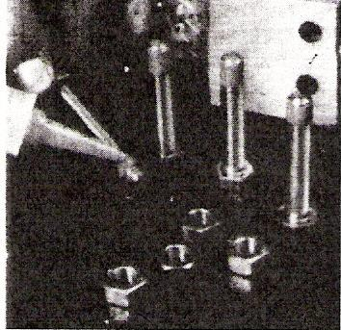
Figure 42 - Thread Locking
Threadsealing pipe fittings The sealant is applied to the clean thread and screwed together as normal. The sealant will not creep or shrink and gives a constant and reliable seal. There is no need to wrench tight and the fitting can be positioned as required.
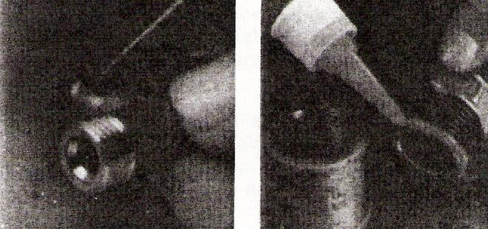
Figure 43 - Thread Sealing
- Hydraulic sealant for fine threads in pneumatic and hydraulic systems – particularly those subject to vibration.
- Pipe sealant used to seal coarse threads of pipes and fittings up to 75 mm outside diameter

Retaining Traditional retaining methods using screws, splines, pins, keys and press fits, etc., do not necessarily seal joints and eliminate the possibility of corrosion. Local stress concentrations may cause cracking. Retaining adhesives can be used to augment these methods. Often, a redesign will give a replacement with substantial cost savings.
These adhesives are supplied in various strengths:
- High shear strength adhesives in association with press fits can provide added rigidity.
- Maximum strength retainers are used on parts which generally do not need to be taken apart.
- Medium strength adhesives suit parts which need frequent disassembly.
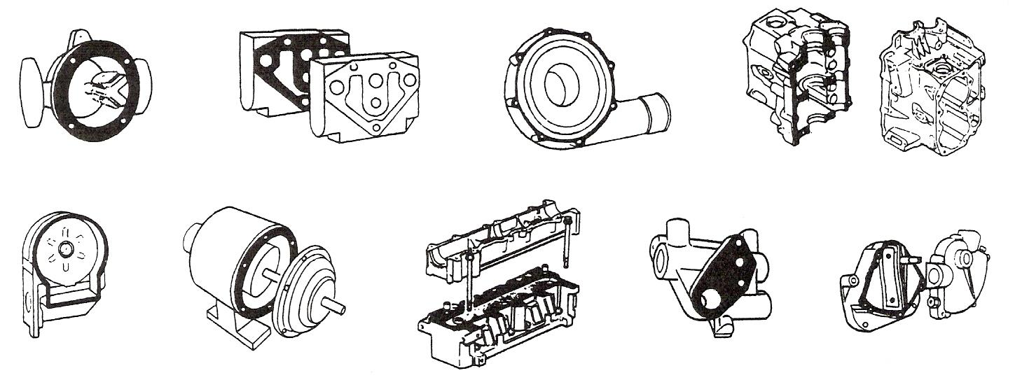
Figure 44 - Retaining
Engineering adhesives for retaining cylindrical assemblies have the following characteristics and applications:
- The retention of shafts and rotors of electric motors, gears, pulleys, sleeves, bushes and oil seals in housings.
- The ability to withstand fatigue and augment torsional strength.
- Suitable for parts that need easy disassembly, such as bearings on shafts and in housings, bushes and journals in soft metals.
- An oil-tolerant adhesive is available that gives high strength retention of parts 'as received', i.e. no cleaning is needed before assembly. Oil impregnated bushes are retained with this grade. They are manufactured by the sintering process.
- An adhesive can be recommended for continuous working temperatures up to 175°C. It combines the ability to fill gaps of up to 0.15 mm in diameter with high shear strength and good solvent resistance.

Instant Adhesives
As the name suggests, they work in seconds and are ideal for bonding close fitting parts made from a variety of materials. They offer advantages over other forms of joining, such as plastic welding, two-part or heat-cured adhesives and mechanical fasteners. The benefits include faster assembly times, better appearance, less outlay for capital equipment and these adhesives can also be used to repair metal, plastic, rubber or ceramic components which might otherwise be scrapped.

Instant adhesives are available for the following applications:

General purpose adhesive for plated metals, composite materials, wood, cork, foam, leather, paper - all surfaces which were once considered 'difficult' - can now be bonded quickly and permanently.
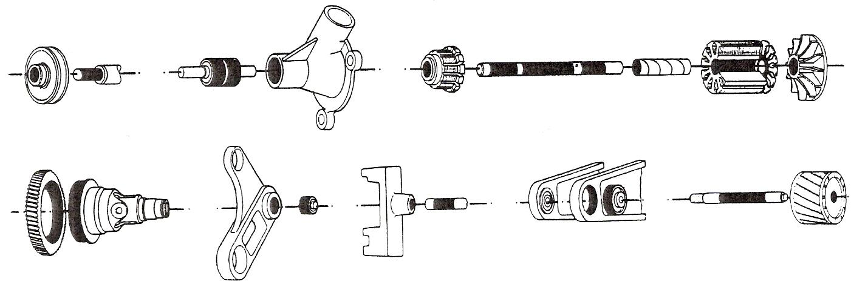
Figure 45 - Instant Adhesives

Lifting and Turning Technology

Lifting Techniques

Kinetic Principles
The Kinetic method of lifting was developed by the religious teachers and monks in the ancient Far East. At that time peasants were not allowed to own weapons and were unable to defend themselves against the ruling Shogun class. In order to teach the people a method of defence, the monks developed martial arts such as Tai Chi, Kwondo, etc., which relied solely on the mind of the person and the amazing movement ability of the human body. The founding principles of martial arts and kinetic lifting are the same;
- lower the centre of gravity by bending the knees
- maintain a wide stance
- get close to your opponent (load)

In this posture, it is very difficult to knock somebody down with a punch or kick. Similarly if you lift an awkward load, by bending your knees you lower the body’s centre of gravity which ensures that your balance is much improved and you are less likely to topple.
A human body’s centre of gravity is about three inches behind the navel. If the body was compressed into a steel rod which ran from this point down to the ground then the weight of the body is said to be acting down this rod.
In Sumo wrestling a favourite move is to move in close to your opponent, grab them by their waist belt and throw them to the ground. As contenders can actually weigh in excess of 20 Stones it is mainly technique which must be employed. Essentially wrestlers are trying to reduce the distance between their own centre of gravity and their opponent’s centre of gravity.
In a manual handling lifting context this is the equivalent of getting a load as close as possible to your own centre of gravity.
Hence, any lifting of a load from the ground to a bench, from one bench to another, a bag of cement or a glass window - is based on the same set of Kinetic principles which is used for all lifting. These key points are known as the BASE MOVEMENT.

Base Movement (8 Key Points)

- Check the Environment and Load
- Broad Stance
- Flat Back
- Bend Knees - Lower your body down
- Head Down
- Firm grip
- Raise head and stand up
- Pull load in close to body

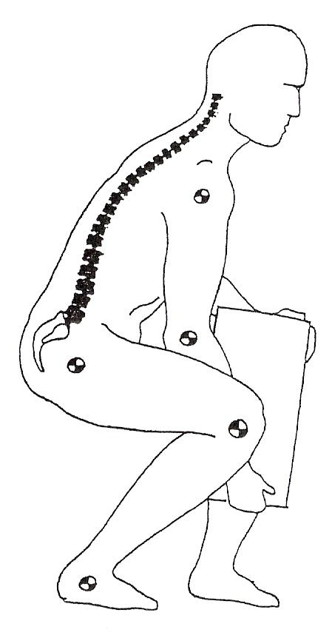
Figure 46 - Base Movement

- Head raised and chin tucked in
- Three spinal curves in place
- Lifting/lowering with legs
- Good grip on opposite corners
- Back 'flat' or straight
- Knees bent
- Feet flat on ground
- Arms between legs
Examining each of these points in detail:

- Check the Environment and Load.
Test the load before you try to lift, it may be too heavy. Wear gloves if it is sharp or rough. Ensure that the path and end location is clear surrounding area. Remember to lower yourself correctly.
- Broad Stance
A comfortable stance with one foot either side of the load if possible. The feet at least hip width apart - this gives balance to the body from side to side. Place one foot slightly in front of the other to maintain balance in the forward/backward direction. The leading foot should be pointing in the direction in which you are going.
- Flat Back
A flat back instead of an upright ram-rod back. The back should not be twisted or bent as it places uneven pressure on the discs.
- Bend Knees
Lower your body by bending at the knees not the back. This keeps the body’s centre of gravity (behind the navel) close to any load to be lifted. The muscles which are used for lifting are the strong thigh muscles and not the weak muscles of the back.
- Head down
If the head is bent down whilst lowering the body, it puts a strain on the back by tightening the muscles at the top of the spine and neck. If safe to do so, only bend the head fully when the body is in a position to lift.
- Firm grip
Place the palm of the hand and roots of the finger under the load rather than just the fingertips. Depending on the object and the distance to be carried, the best grip is to place one hand under the load and the other hand at the top of the opposite diagonal comer.
- Raise the head and stand up.
Upwards movement begins by raising the head with the chin remaining in a natural/comfortable position. Stand up by using the strength of the leg muscles. Use momentum if possible but be wary of losing balance.
- Pull load in close to body
By having the load as close as possible to your body it is getting closer to the body’s centre of gravity. This reduces the effort and force required to lift or carry the load. Keep your elbows into your side.

Common Lifts
The base movement is used in the common types of lifts described below. A number of additional points to be aware of are also outlined.

- Lifting a load from the floor
The most common lift of them all. Keep arms inside legs. Try not to hyperflex (over-bend) at the knees. Take a deep breath particularly if the load is heavy.
- Placing or dropping a load onto the floor
Take up a base position so that the load can be placed between the legs. Lower the load to the floor by relaxing at the knees and bringing the head down last. Try not to hold the load in mid-drop, the faster the load is placed then the less effort that is required.
- Placing a load onto a table at waist height
Approach the bench squarely. Place the leading foot under the bench or as near to it as possible. Continue the movement by bringing the other foot up to the bench, comfortably apart and slightly to the rear. Lower the load by relaxing the knees - take care not to trap the fingers under the load. Push the load in from the edge whilst knees are still bent.
- Removing a load from a table at waist height
Approach the bench squarely. Place the leading foot under the bench or as near to it as possible. Continue the movement by bringing the other foot up to the bench, comfortably apart and slightly to the rear. Lower body by relaxing the knees.
Test the load. Take a good palm grip at the bottom sides of the load. Pull the load to the edge of the table. Pull one corner of the load off the table, if safe to do so, and get a good palm grip. Pull the load into the abdomen. Take a deep breath, look up, and stand up. Take the load on one foot. Move the other foot to the rear or to the side and walk away, keeping the elbows into the sides.
- Placing a load under a table
The first step is to place the load on the ground. Place one leg to the side of the load pointing in the direction of movement. Place the other leg just behind and parallel to the load. Place your hand/arm between this leg and the load. Use this arm and the power of the leg behind it to push the load under the table. The other hand may be used to direct the load.
- Removing a load from under a table
The first step is to lower the body to a kneeling position. Take up a base position. Lower the body by relaxing at the knees and go down onto one knee. Ensure that the toes on the bent leg are not uncomfortable by turning the foot outwards.
Reach in under the bench. Test the load. With a firm grip of the load, lean the upper body back over the legs, do not use the arms. Do this a number of times until the load is clear of the bench. Note that this is not a position to lift from. Lifting can only be accomplished by repositioning: i.e. standing up.

- Placing a load from waist to above
This lift should be carried out in a smooth fashion, and it may be possible to use the momentum of a walking body to assist in movement of the load. If the load is being held in a diagonal hold then a change in grip may be required. The base stance (wide, diagonal) to be used.
- Removing a load from above
Check to see if any items on top of load. Grip load as low as possible.
Pull load close into stomach waist as it descends. Base stance to be used.
- Pushing and Pulling
Same base movements as other lifting situations. Keep the arms straight, bend at knees and push/pull with legs. Pushing is usually less severe on the spine than pulling.

Forces and Levers
We can think of the body as a mechanical machine which uses forces and levers to lift, similar to a crane. Forces developed by muscles act on the bones through the tendons at the point where the tendon enters or inserts into the bone, and cause rotation or the application of force around or at a joint. This is known as torque: the movement of an arm or leg is torque. The axis of rotation, or fulcrum, is at the centre of a joint, such as the elbow, shoulder, knee or hip.

The muscles and bones act as a series of levers. When you lift a box with both arms, the box acts as a load or resistance on a lever, the forearm.

In principle, the nearer the load to be lifted is to the fulcrum (the shorter the load arm distance), the smaller is the force needed to be exerted in the force arm to lift a given weight.
For a practical illustration of this principle, consider lifting a load, a box. The levers involved are the back and the arms. The backs fulcrum is very close to the body’s centre of gravity, a position about three inches behind the navel, and the force arm is the remaining distance from this point to the back muscles. The arms fulcrum is in the elbow, just behind the crease and the remaining distance to the back of the elbow is its force arm.
The distance from the box/load to these fulcra is the load arm(s). Thus, if the worker holds the box out from his body, the load arm distance will be great with a correspondingly high amount of force required to lift the load. If he holds the load in close to his body, the force required to be exerted on the force arms will be reduced considerably.
If the load is lifted with arms outstretched, then the force required to do this is at least 3 times as much as lifting the load close to the body.

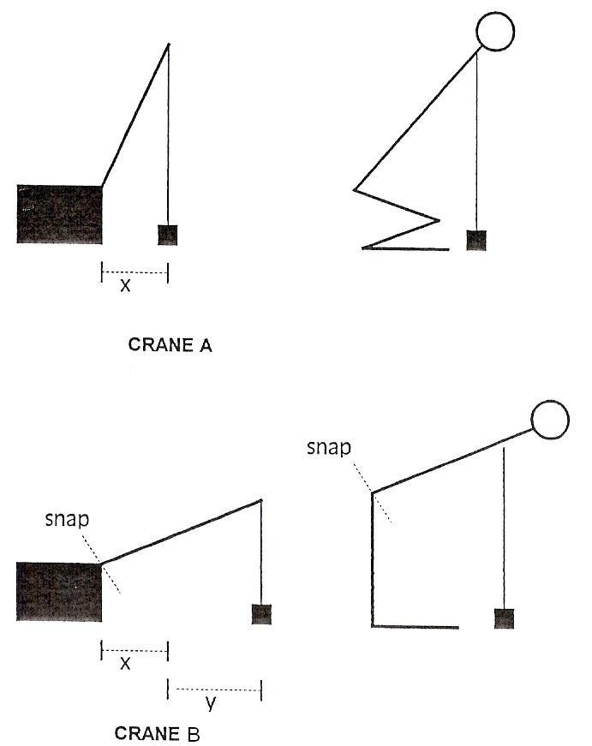
Figure 47 - Forces and Levers

Clothing
Having the correct clothing is very important for ensuring that there is a safe lift. Clothing should be loose and comfortable to enable you to squat with ease; tight jeans are to be avoided. There should be no loose flaps, buttons, or screwdrivers in pockets, etc. which may catch on objects and become a danger. Wear well-fitting flat shoes with a good grip, and toe caps/safety shoes if necessary. Wear gloves if you are handling metal, wood, corrosives or slippery materials. Women should be encouraged to wear trousers, otherwise through modesty or restriction of the clothing they are likely to twist to the side when squatting to lift an object up.
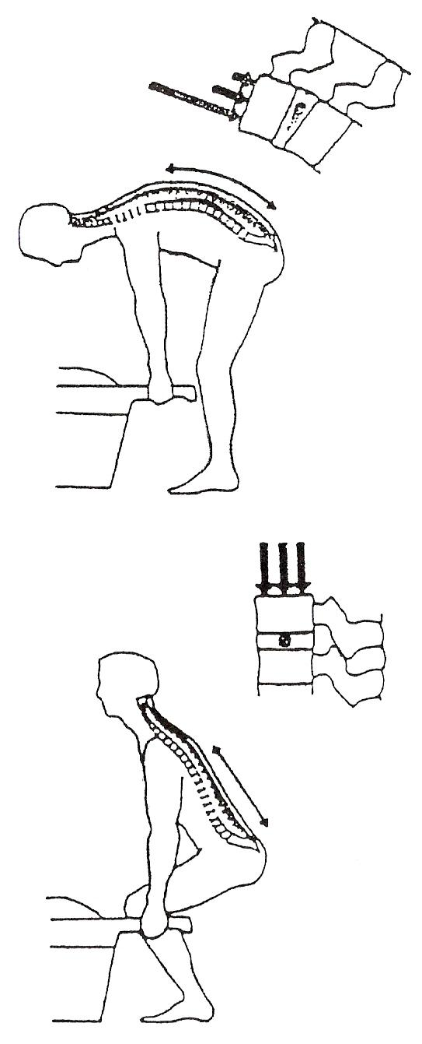
Figure 48 - Symmetrical and Asymmetrical Inverted Disc Loading

Manual Handling of Loads Regulation 27 – 28
The Regulation provided a definition of manual handling and also outlined the duties of the employer.

Definition: "manual handling of loads"
- any transporting or supporting of a load by one or more employees, and includes lifting, putting down, pushing, pulling, carrying or moving a load, which by reason of its characteristics, or of unfavourable ergonomic conditions, involves risk, particularly of back injury, to employees.

Duties of Employer:
A summary of these duties is outlined below:

- Take steps to avoid manual handling if possible;
- use mechanical equipment
- good workplace organisation
- Assess the risk of injury from any task which cannot be avoided;
- assess the load, individual, activity & workplace
- schedules 8 & 9 outline these points in detail (see below)
- Reduce the risk by putting in place appropriate safety measures;
- implement any changes required based on the risk assessment.
- Provide training and information to employees;
- an adequate manual handling course
- specific information (if available) on the item to be lifted, i.e., the weight and centre of gravity.
Schedules 8 & 9
Schedules 8 & 9 are legal guidelines attached to the Manual Handling Regulations and are used when carrying out a risk assessment.
Schedule 8 - Reference factors for the Manual Handling of Loads
- Characteristics of the Load
The manual handling of a load may present a risk particularly of back injury if it is:
- too heavy or too large
- unwieldy or difficult to grasp
- unstable or has contents likely to shift
- positioned in a manner requiring it to be held or manipulated at a distance from the trunk, or with a bending or twisting of the trunk, or
- likely, because of its contours or consistency (or both), to result in injury to employees, particularly in the event of a collision
- Physical Effort Required
A physical effort may present a risk particularly of back injury if it is:
- too strenuous
- only achieved by a twisting movement of the trunk
- likely to result in a sudden movement of the load, or
- made with the body in an unstable posture
- Characteristics of the Working Environment
The characteristics of the working environment may increase a risk particularly of back injury if:
- there is not enough room, in particular vertically, to carry out the activity
- the floor is uneven, thus presenting tripping hazards, or is slippery in relation to the employee's footwear
- the place of work or the working environment prevents the handling of loads at safe height or with good posture by the employee
- there are variations in the level of the floor or the working surface, requiring the load to be manipulated on different levels
- the floor or foot rest is unstable
- the temperature, humidity or ventilation is unsuitable
- Requirements of the Activity
This activity may present a risk of back injury if it entails one or more of the following requirements:
- over-frequent or over prolonged physical effort involving in particular the spine
- an insufficient bodily rest or recovery period
- excessive lifting, lowering or carrying distances, or
- a rate of work imposed by a process which cannot be altered by the employee
Schedule 9 - Individual Risk Factors
The employee may be at risk if he:

- is physically unsuited to carry out the task in question
- is wearing unsuitable clothing, footwear or other personal effects
- does not have adequate or appropriate knowledge or training.

European Legislation
As a Member State of the EU, we come under all Safety Directives formulated by the Commission. Each Directive is directly enforceable as law; however, the idea is that each Member State will codify each one into their own legislature in the form of an Act or Regulation, etc. In 1989, what is known as the Framework Directive, 89/391/EEC was passed. This is a general, 'umbrella' or framework Directive, essentially similar to our 1989 Act.

This has been followed by what are known as Individual or 'Daughter' Directives, which address specific issues of safety, similar to our own Regulations stemming from an Act.

Also similar to the Framework Directive, each one is to be adopted by the member states. The first five individual Safety Directives have thus been adopted into Irish legislation in the form of the aforementioned 1993 General Application Regulations.

Manual Handling of loads Directive, 90/269/EEC, is virtually identical to the Irish Manual Handling Regulation of 1993.

Material Removal

Movement of Materials under Adverse Conditions
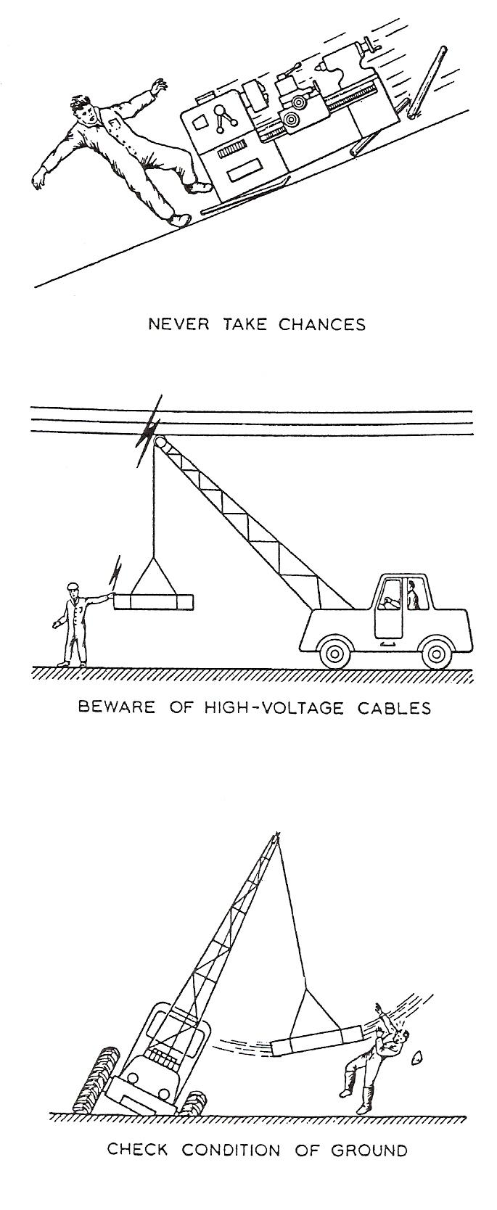
The movement of objects and materials is often made more difficult by obstructions which cannot be moved, steep inclines, and adverse weather conditions, or hidden dangers such as stepping on an asbestos roof when manhandling an object, unsound floor or soil conditions, and movement near machinery which, although stationary, may suddenly start up. These and many other forms of danger mean that great forethought and care must be taken when adverse conditions are encountered.

Movement in the Workshop
Advise the works safety officer if the movement of any object is considered to be risky. Contact the workshop supervisor, who will decide if any machines need shutting down.
Take care when transporting overhanging loads through narrow passageways, especially when flanked by machines and other equipment. Watch overhead clearance. Keep clear of processes involving molten metals or acids. Always ensure you have adequate lighting. Take care if decorators or builders are working on scaffolding. Watch for unfenced holes.

Movement on Site
Adverse weather conditions, such as fog, blinding rain or snow, can obstruct the vision. Pay attention to soil conditions. Check bridge plates before you cross them. If movement is along scaffolding watch for loose boards or missing handrails. When operating cranes watch overhead clearance and take particular care if overhead electric cables are nearby. Railway lines or roads sometimes pass through factories or may be near sites - always take care when moving objects near to or over them.

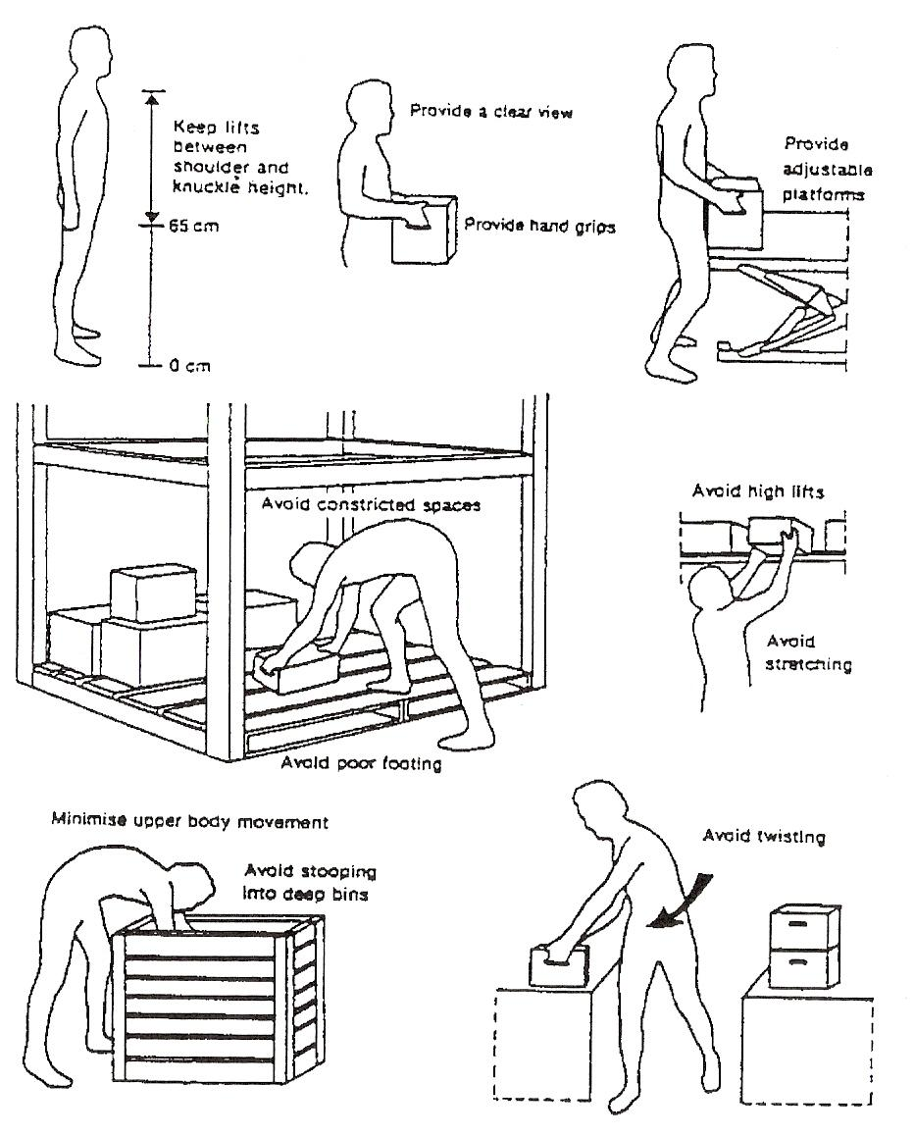
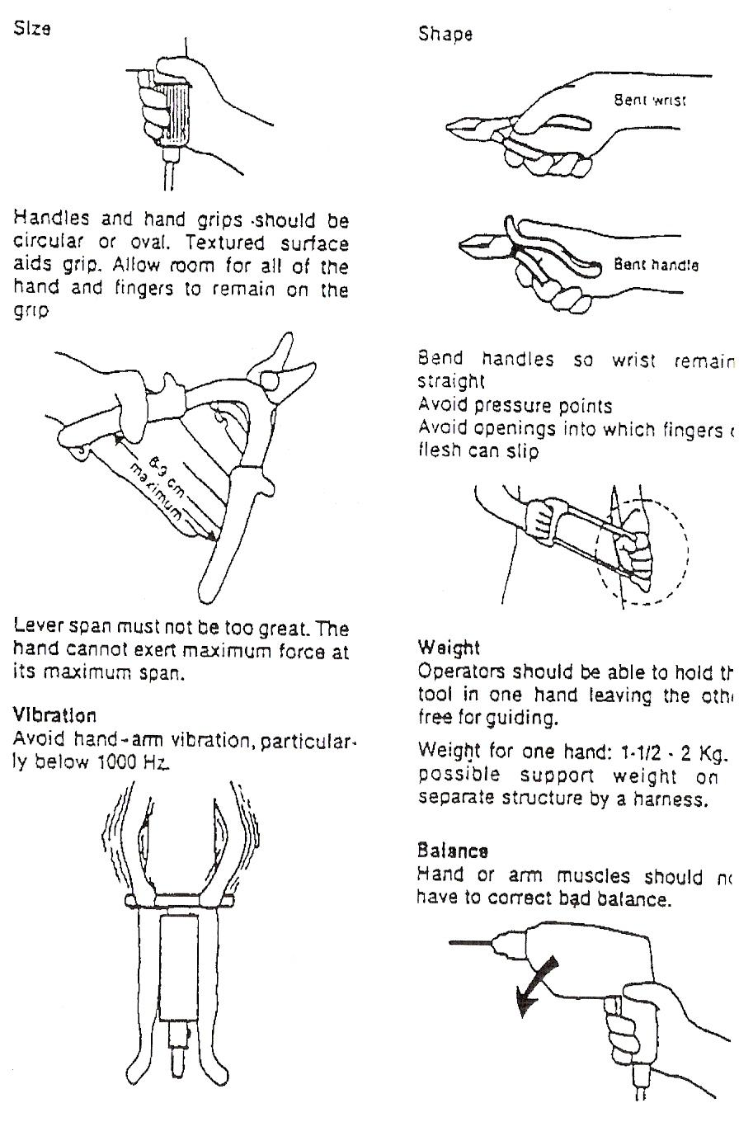
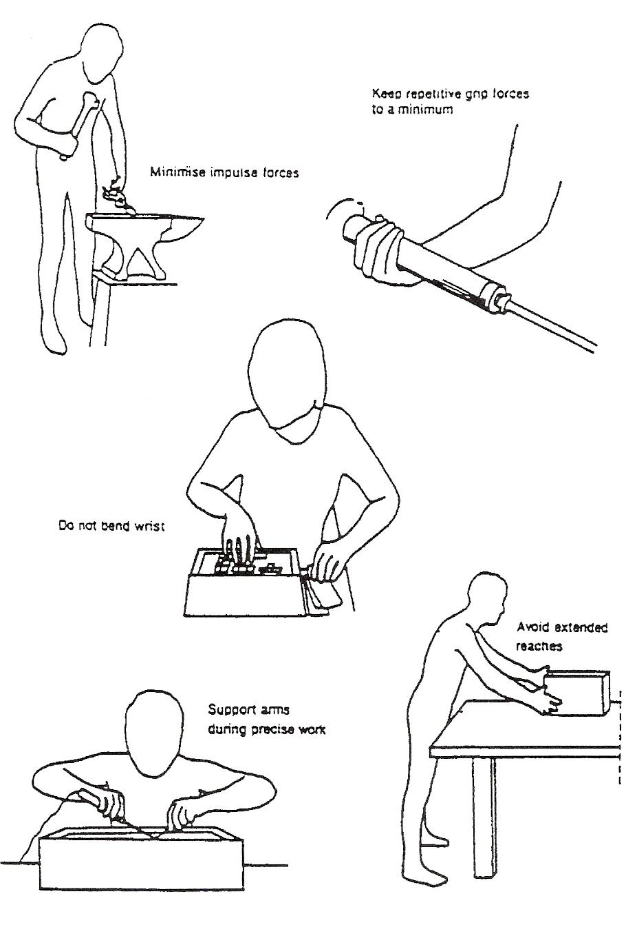
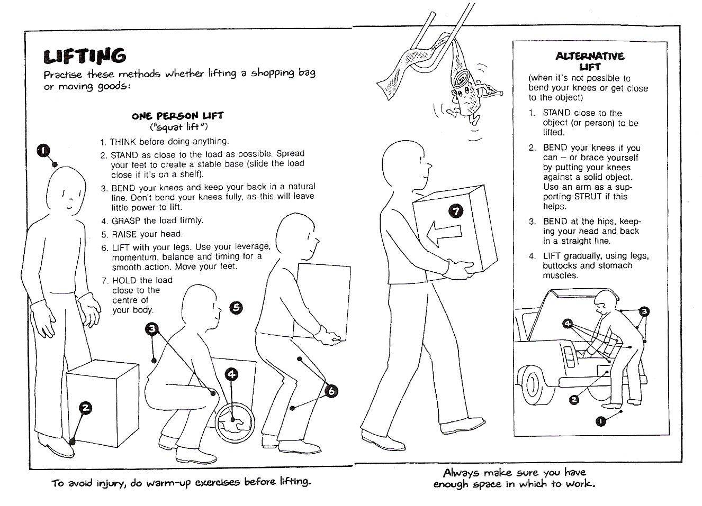
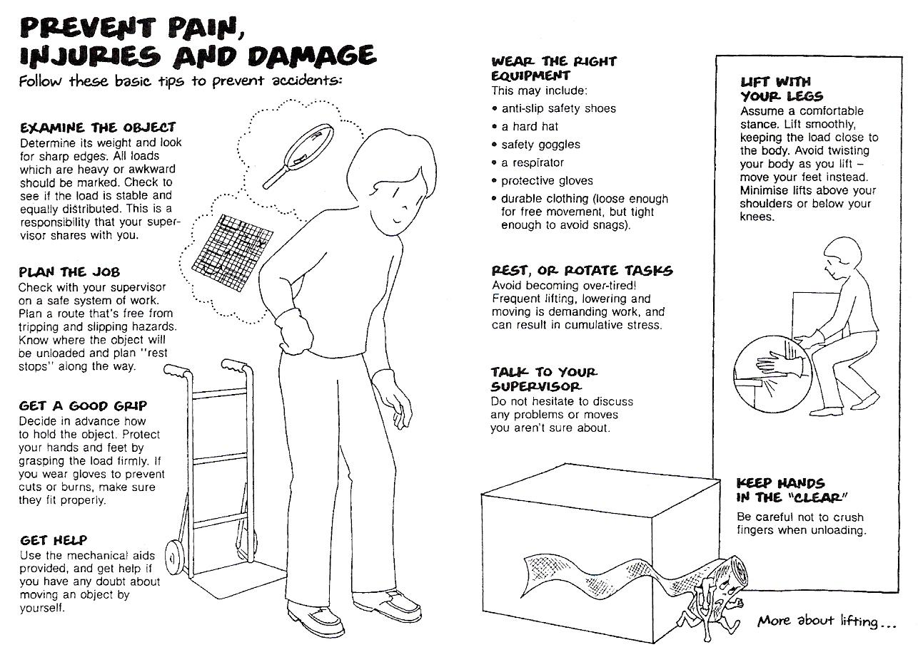
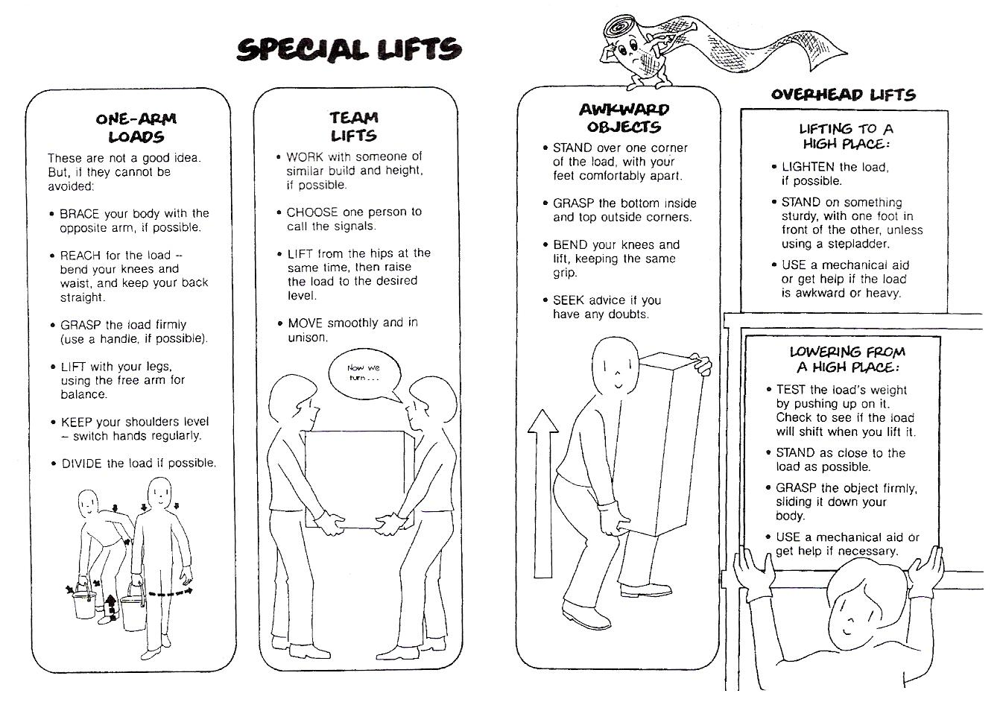
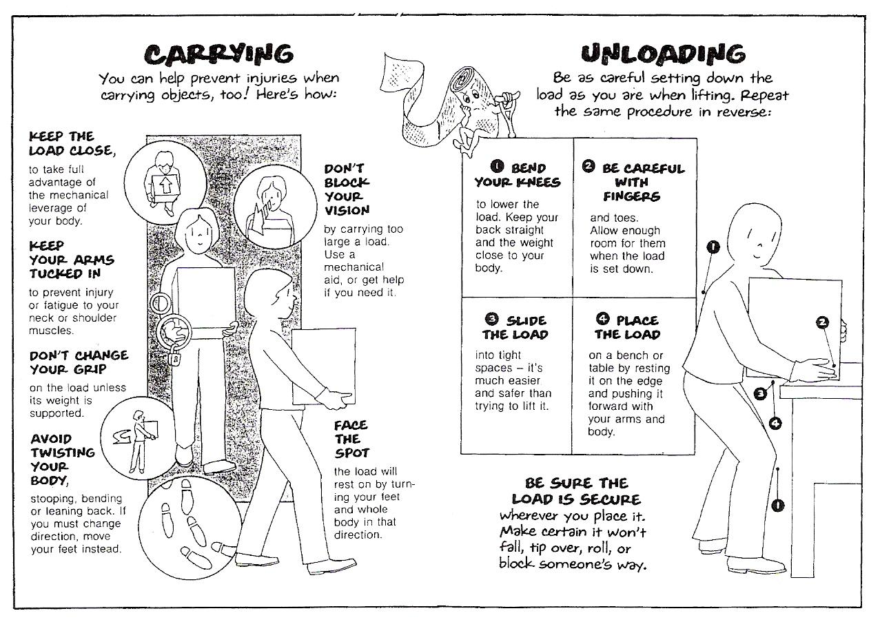


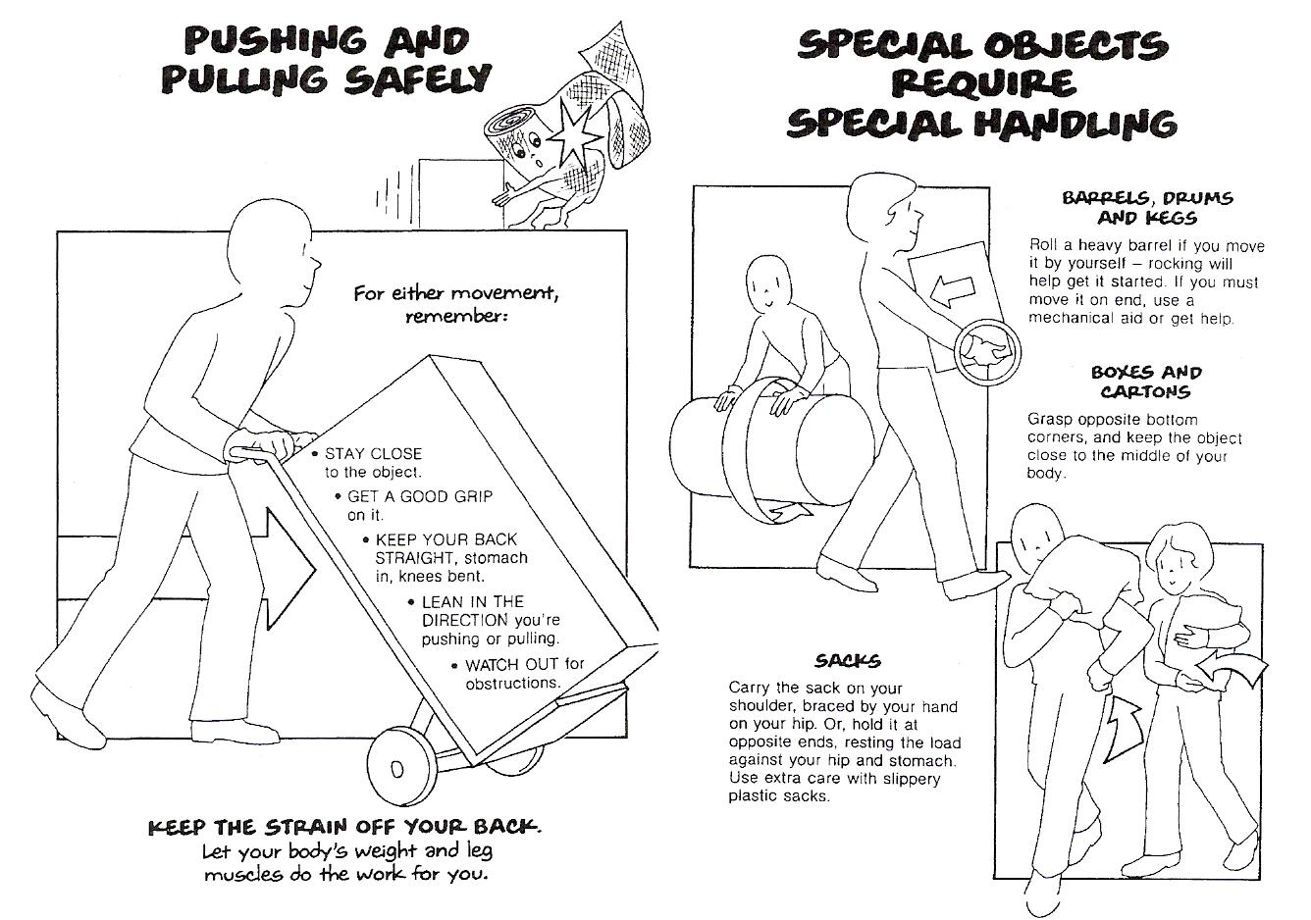

Structural Engineering
From Wikipedia, the free encyclopaedia
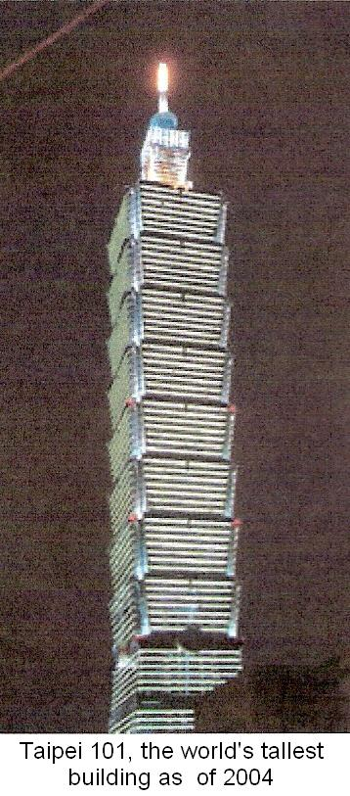
It has been suggested that Structural Engineer be merged into this article or section. (Discuss)
Structural engineering is a field of engineering that deals with the design of any structural system(s), the purpose of which is to support and resist various loads.
Most commonly structural engineers are involved in the design of buildings and non-building structures, but also play an essential role in designing machinery where structural integrity of the design item is a matter of safety and reliability. Large man-made objects - everything from furniture to medical equipment and from vehicles (trucks, aircraft, spacecraft and watercraft) to cranes - require the input of a structural engineer.
In building construction, the structural engineering field is a subset of civil engineering. In a practical sense, structural engineering is largely the application of Newtonian mechanics to the design of structural elements and systems that support buildings, bridges, walls (including retaining walls), dams, tunnels, etc.
Structural engineers ensure that their designs satisfy a given design intent predicated on safety (i.e. structures do not collapse without due warning) and on serviceability (i.e. floor vibration and building sway do not result in occupants criteria discomfort). In addition, structural engineers are responsible for making efficient use of funds and materials to achieve these goals. Typically, entry-level structural engineers may design simple beams, columns, and floors of a new building, including calculating the loads on each member and the load capacity of various building materials (steel, timber, masonry and concrete). An experienced engineer would tend to render more difficult structures, considering physics of moisture, heat and energy inside the building components.
In the United States, the structural engineering field is often subdivided into bridge engineering and structural engineering for buildings. Additionally, structural engineers often further specialise into special structure manufacture or construction, such as pipeline engineering or industrial structures.
Structural loads on structures are generally classified as: live loads such as the weight of occupants and furniture in a building, the forces of wind or weights of water, the forces due to seismic activity such as an earthquake, dead loads including the weight of the structure itself and all major architectural components and live roof loads such as material and manpower loading the structure during construction. Structural engineers mainly fight against the forces of nature like winds, earthquakes and tsunamis. In recent years, however, reinforcing structures against sabotage has taken on increased importance.
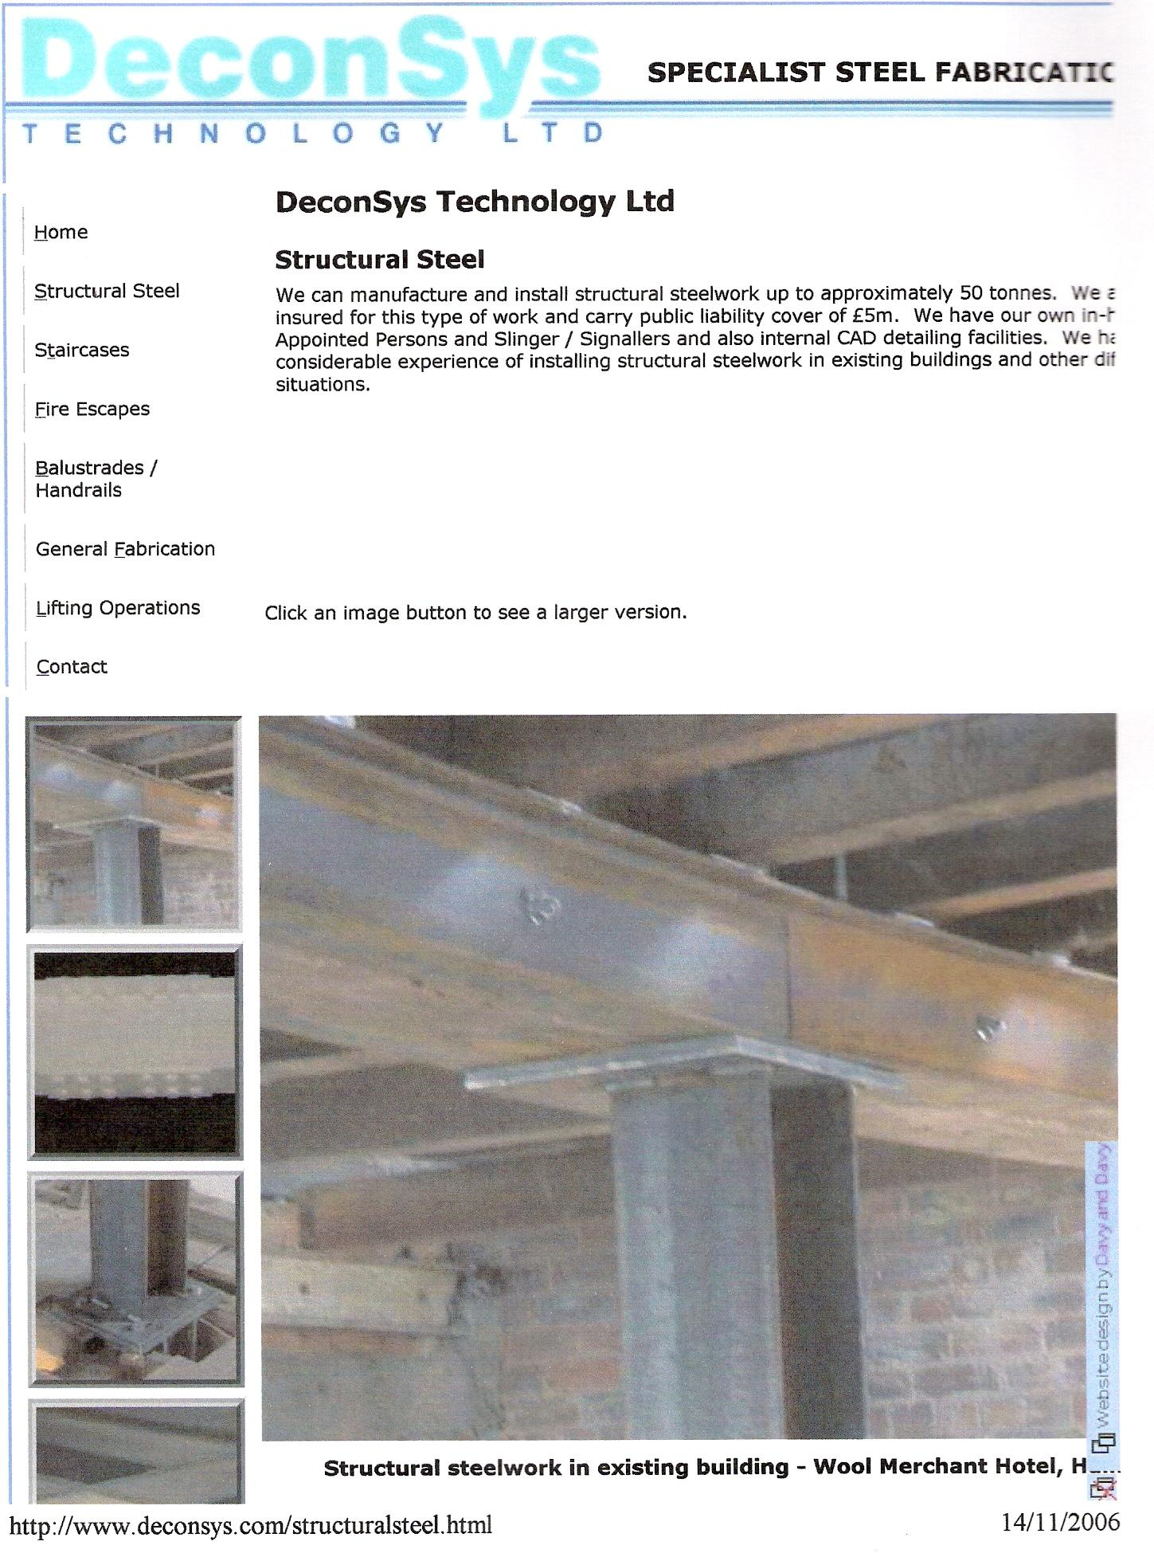
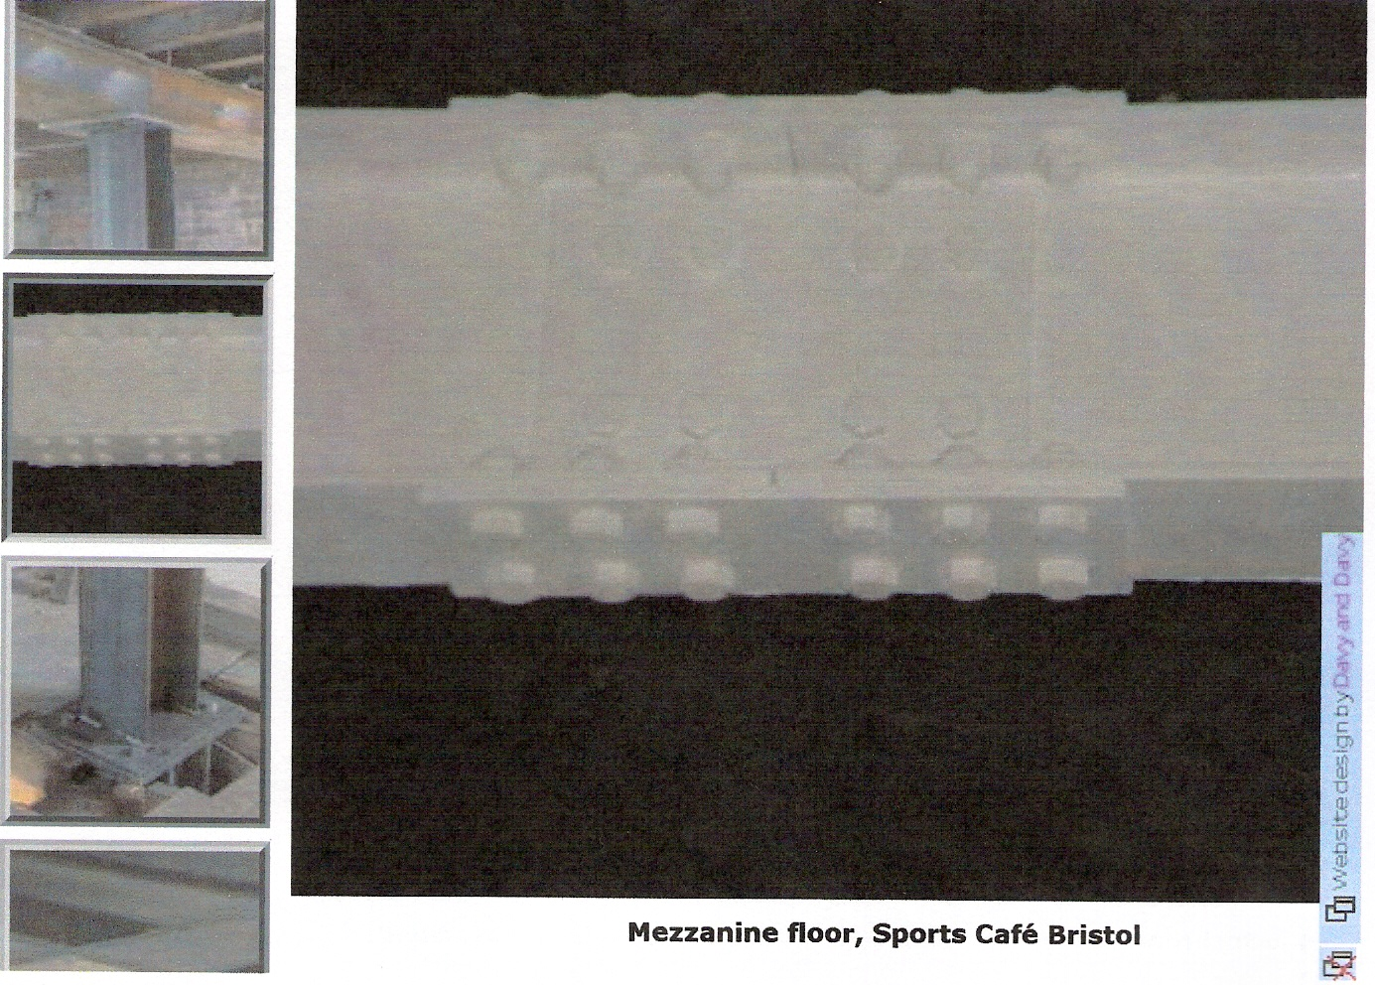

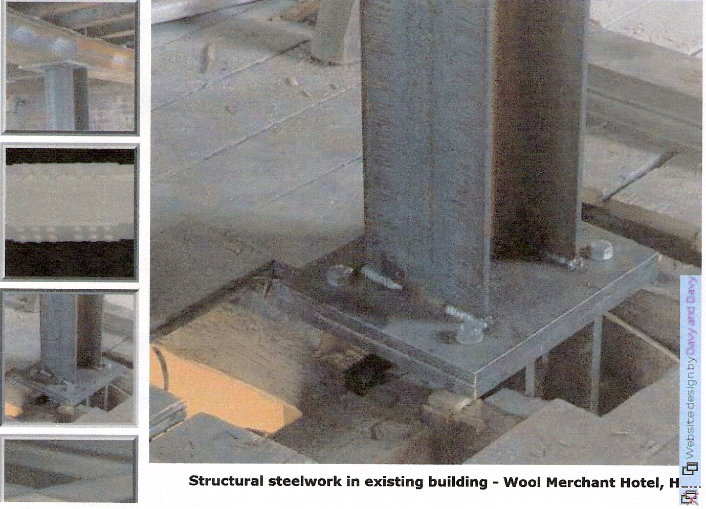

Appearance, Strength and Safety in Fabricated Structural Members
When structural steelwork is designed, fabricated and erected, certain important points must be considered. The three most important points are as follows (not necessarily in order of importance).

Appearance
A fabrication should always be pleasant to look at whether it is a ship, an aeroplane, a bridge or a barn. Cambers are often introduced into structural work because they are pleasant to look at as well as providing stiffness and clearance. Sharp or abrupt angles, especially on welded beam connections, are nowadays smoothed into radii where possible, which improves both appearance and fatigue life. With the introduction of welding into highly stressed fabrications, beautiful modern designs are possible, providing smooth contours, which can also attain the highest joint strength.

Appearance is largely in the hands of the designer, but the fabricator who takes a pride in his work can certainly, by good workmanship, improve the general appearance - for example, not leaving snap and hammer marks or stray arcing on plates and sections, deslagging welds and removing buckles. Friction grip bolts should have a uniform appearance, i.e. all heads or nuts on the same side with uniform thread. Fit-up of plates is extremely important and rivets should be uniform and not burnt. Long length flanges and stiffeners, if buckled or twisted, look most unsightly and should be avoided. Excessive drifting and straining of members should always be avoided. Surface weld defects and excessive spatter not only indicate poor workmanship and appearance, but very often that the joint strength is not of the highest.

Stanchions and trusses should be aligned to prevent sagging during assembly on a previously levelled bench area or block, and marked clearly for site erection, where required. Remember, a general tolerance for fabricated steelwork is usually ±1 mm for single dimensions, to ±2 mm for multiple dimensions.

Strength
It is said that a chain is as strong as its weakest link, and this may be said with regard to fabricated structures. The tensile strength of low carbon structural steel is 450 N/mm² and 700 N/mm² for low alloy structural steel, but it is the joint strength of the connecting members which is important. If the joint is incorrectly or badly made, either during riveting, bolting or welding, then failure may occur during service.
Butt joints and stanchion splices which transmit compressive stress should be assembled with care and accuracy to prevent unequal loading. Base gussets, angles or channels should be fixed with such accuracy that they are not reduced in thickness after machining by more than 1.6 mm. Care should be taken to ensure that the clearances specified are worked to. The erection clearance for cleated ends of members connecting steel to steel should not be greater than 1.6 mm at each end. The erection clearance at the ends of beams without web cleats should not be more than 3.8 mm at each end. If, for practical reasons, the clearance has to be increased, the seating should be suitably designed. The correct standard back marks and edge distances should be worked to unless otherwise stated.
Holes through more than one thickness, such as compound stanchions and girder flanges, should be clamped or bolted together and drilled. Punching is permitted before assembly if the holes are punched 3.2 mm less and reamed to final size after assembly. The thickness of material punched should not be more than 16 mm and all sharp burrs removed.
Care should be taken when lifting and slinging, especially with roof trusses, otherwise straining will take place and make erection extremely difficult. The sequence of erection should be correct and bracing should be safe and adequate.

Web Stiffeners
As the name implies, these are (1) for making the webs of built-up members more rigid to withstand buckling and twisting due to imposed loads and (2) to transmit the load and prevent the toes of flanges buckling upwards (Fig. 49.2). The stiffeners may be welded (Fig. 49.1) or bolted or riveted (Fig. 49.2). The welding of stiffeners to a tension flange of a fabrication subject to fatigue loading is not recommended due to the lowering of fatigue life. An overhead crane and its supporting girders are typical examples of fatigue loading.

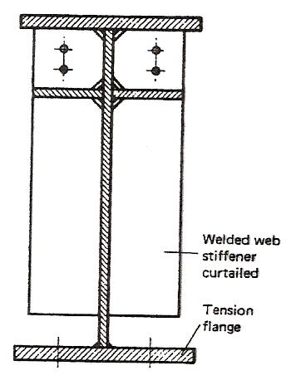
Figure 49 - Welded Fabricated Beam
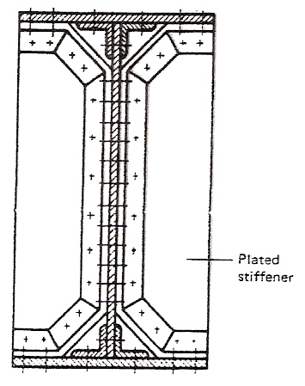
Figure 50 - Riveted or H.S.F.G. Bolted Beam

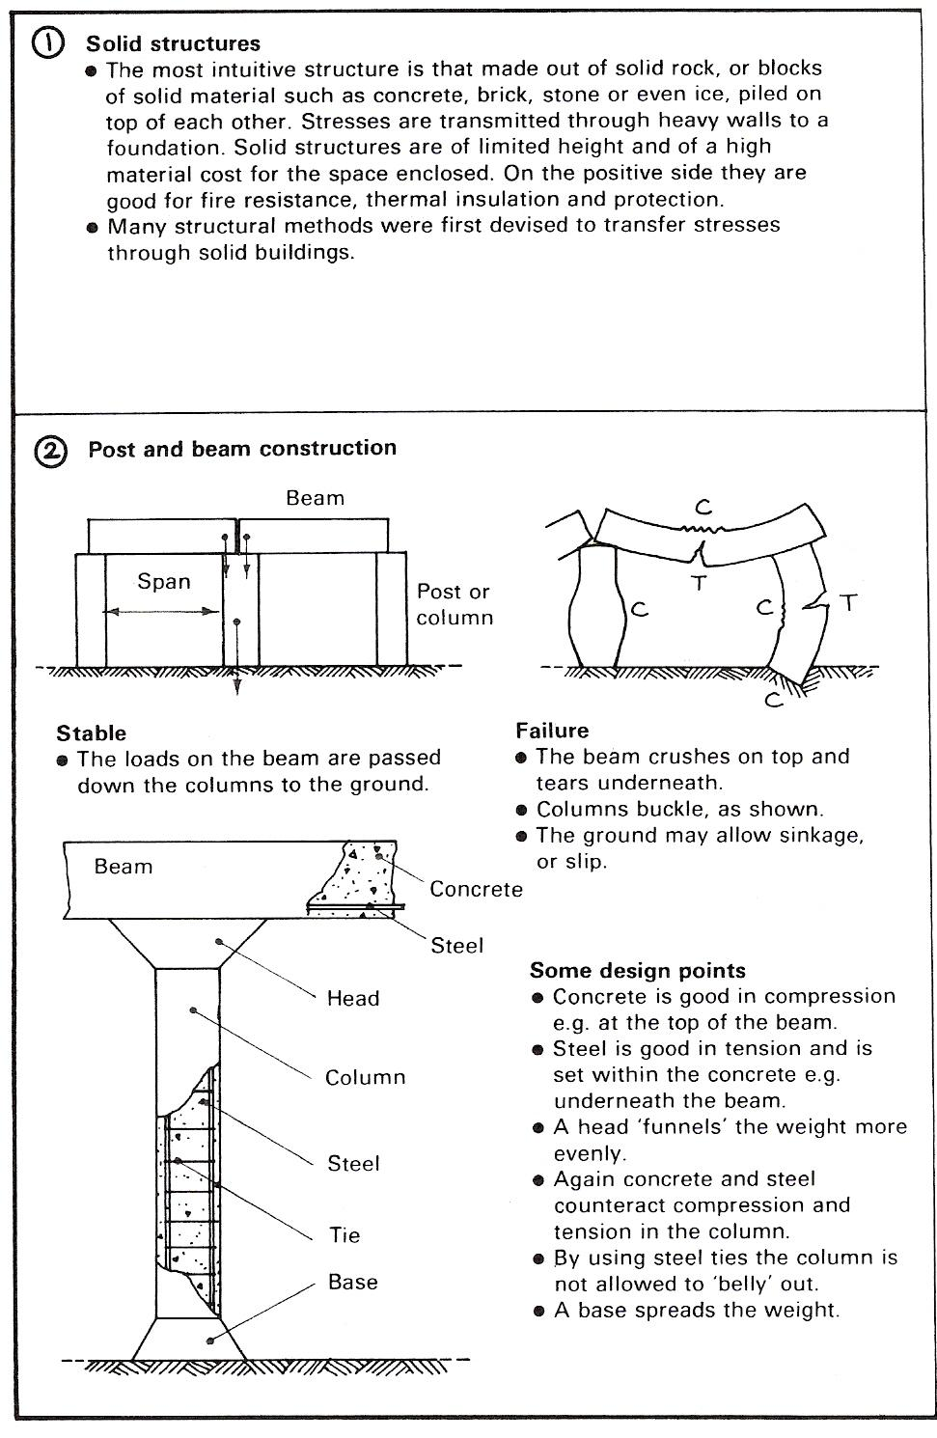

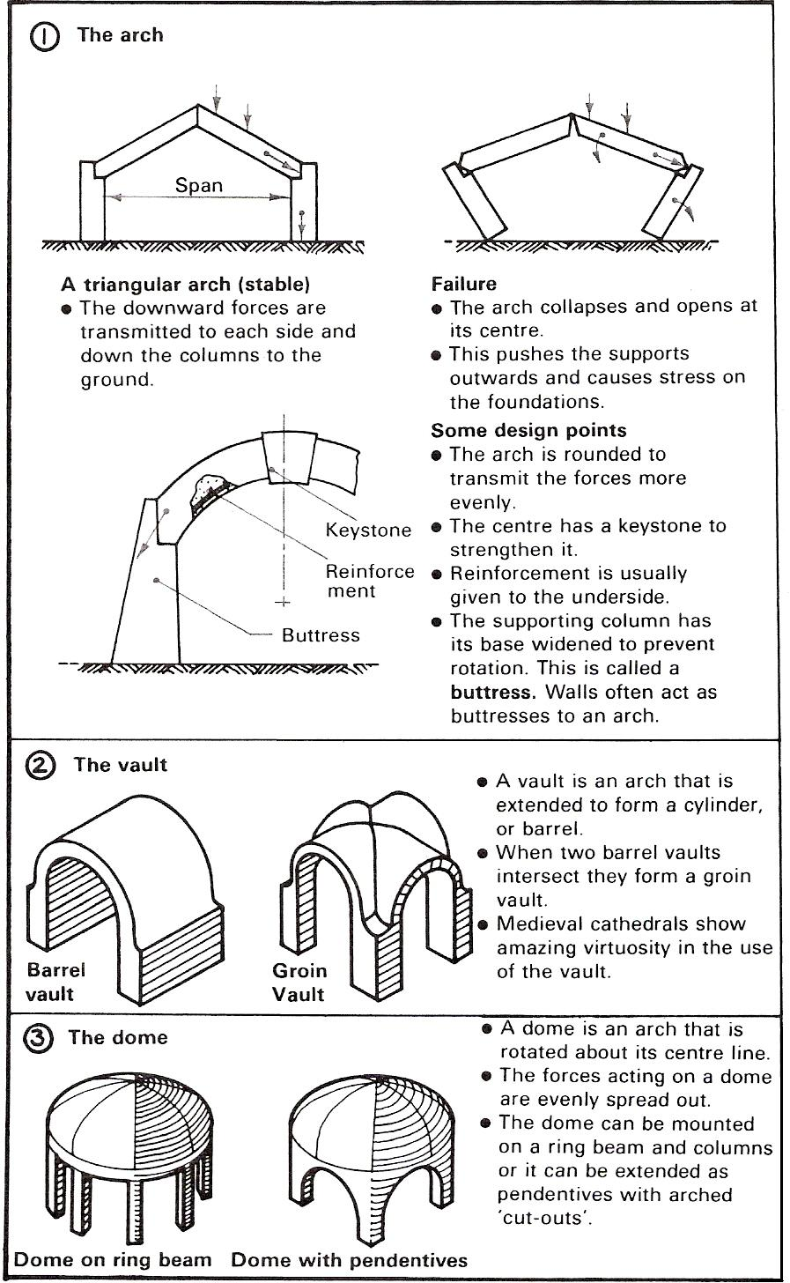

Bolted Joint
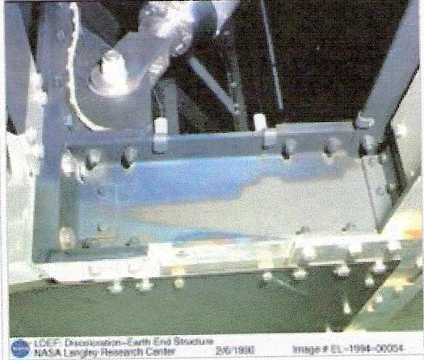
Figure 51 - Bolted Joint

Bolted joints are one of the most common elements in construction and machine design. They consist of cap screws or studs that capture and join other parts, and are secured with the mating of screw threads.
There are two main types of bolted joint designs. In one method the bolt is tightened to a calculated torque, producing a clamp load. The joint will be designed such that the clamp load is never overcome by the forces acting on the joint (and therefore the joined parts see no relative motion).
The other type of bolted joint does not have a designed clamp load but relies on the shear strength of the bolt shaft. This may include clevis linkages, joints that can move, and joints that rely on locking mechanism (like lock washers, thread adhesives, and lock nuts).

Contents:
- Theory
  - Thread strength
- Setting the torque
- Property class
- Failure modes
- Types of bolts
- Locking mechanisms
- See also
- External links
- References

Theory
The clamp load, also called preload, of a cap screw is created when a torque is applied and is generally a percentage of the cap screw's proof strength. Cap screws are manufactured to various standards that define, among other things, their strength and clamp load. Torque charts are available that identify the required torque for cap screws based on their property class.
When a cap screw is tightened it is stretched, and the parts that are captured are compressed. The result is a spring-like assembly. External forces are designed to act on the parts that have been compressed, and not on the cap screw.
The result is a non-intuitive distribution of strain; in this engineering model, as long as the forces acting on the compressed parts do not exceed the clamp load, the cap screw doesn't see any increased load. This model is only valid when the members under compression are much stiffer than the capscrew.
This is a simplified model. In reality the bolt will see a small fraction of the external load prior to it exceeding the clamp load, depending on the compressed parts' stiffness with respect to the hardware's stiffness.

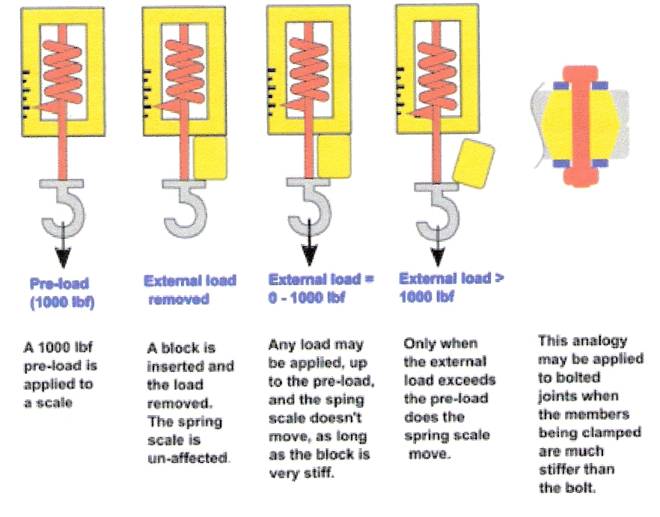
Figure 52 - Bolted Joint Loads
The results of this type of joint design are:
- Greater preloads in bolted joints reduce the fatigue loading of the hardware.
- For cyclic loads, the bolt does not see the full amplitude of the load. As a result, fatigue life can be reduced or, if the material exhibits an endurance limit, extended indefinitely.
- As long as the external loads on a joint don't exceed the clamp load, the hardware doesn't see any motion and will not come loose (no locking mechanisms are required).

In the case of the compressed member being less stiff than the hardware (soft, compressed gaskets for example) this analogy doesn't hold true. The load seen by the hardware is the preload plus the external load.

Thread Strength
Nut threads are designed to support the rated clamp load of their respective bolts. If tapped threads are used instead of a nut, then their strength needs to be calculated. Steel hardware into tapped steel threads require a depth of 1.5 x thread diameter to support the full clamp load.
If an appropriate depth of threads are not available, or they are in a weaker material than the cap screw, then the clamp load (and torque) needs to be de-rated appropriately.
Threads are usually created on a thread rolling machine. They may also be cut with a lathe, tap or die. Rolled threads are about 40% stronger than cut threads.

Setting the Torque
Engineered joints require the torque to be accurately set. The clamp load produced during tightening is about 75% of the fastener's proof load. Over tightening will damage threads and stretch the bolt, ruining the joint's strength; see Hooke's law.
If the hardware is Cadmium plated, or lubricated (or both) the torque is reduced by 15-25% to achieve the same clamp load. Speciality coatings exist that allow for a reduction of 50% in torque (compared to non-plated, non-lubricated hardware) to achieve the designed clamp load.
Torquing the bolt is notoriously inaccurate. Even with a calibrated Torque wrench large errors are caused by dirt, surface finish, lubrication, etc. The turn of the nut (http://www.boltscience.com/pages/tighten.htm) method is more accurate, but requires additional calculations and tests for each application.
There are more expensive tools for accurate torque setting, like ultrasonic meters, but they are out of reach of most shops.

Property Class
There are many different property classes (grades) of bolts and nuts. The most common are listed below. Note that each nut property class listed can support the bolt proof strength load of the bolt it is listed beside without stripping.

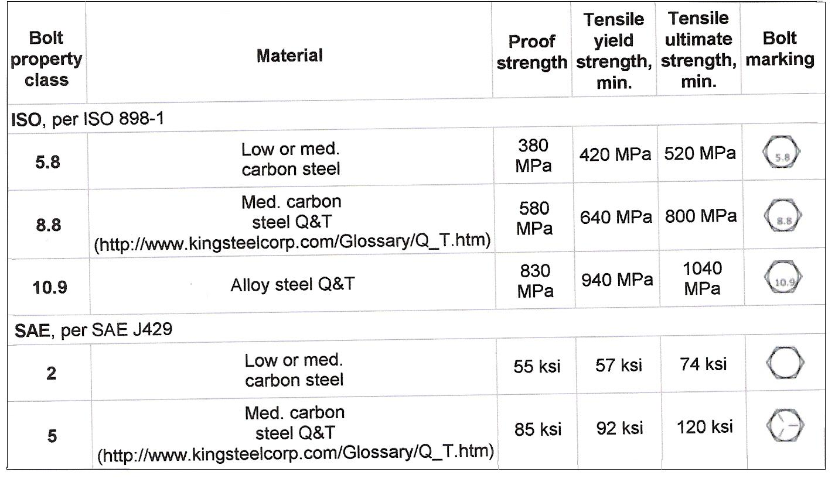
Table 1 - Property Classes

Failure Modes
The most common mode of failure is overloading. Operating forces of the application produce a load that exceeds the clamp load and the joint works itself loose, or fails catastrophically. Something that is not considered structural failure, but nevertheless is becoming a modern annoyance in new buildings is bolt banging.

Over torquing will cause failure by damaging the threads and deforming the hardware, the failure might not occur until long afterwards. Under torquing can cause failures by allowing a joint to come loose. It may also allow the joint to flex and thus fail under fatigue.

Brinelling may occur with poor quality washers, leading to a loss of clamp load and failure of the joint.

Corrosion and exceeding the shear stress limit are other modes of failure.

Types of Bolts
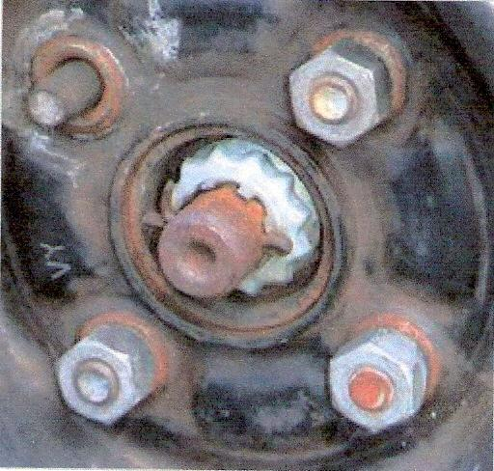
Figure 53 - Types of Bolts

Bolted joints in an automobile wheel. Here the outer four screws are studs that project through the brake drum and wheel, while nuts with conical locating surfaces secure the wheel. The central nut (with cotter key) secures the wheel bearing to the steering spindle. Other configurations use a bolt into threaded holes in the axle end or brake drum.
- cap screw
- machine screw
- stud

Locking Mechanisms
Locking mechanisms keep bolted joints from coming loose. They are required where the clamp load is low or non existent, where inexpensive hardware is used, or where additional safety is warranted.
- two nuts, tightened on each other.
- lock nut (prevailing torque nuts)
- polymer insert
- oval lock
- lock washer
- thread adhesive
- lock wire, castellated nuts/capscrews (common in the aircraft industry)

See Also
- Screw
- Rivet
- Bolt manufacturing process
- Quenching and Tempering (Q&T)

External Links
- Bolt Science Website (http://www.boltscience.com)
- Metric Bolt Properties, Grades, and Strength (http://euler9.tripod.com/bolt-database/22.html)
- Printable tools for determining bolt sizes (http://www.boltdepot.com/fastener-information/PrintableFastener-Tools.aspx)

References
Jack A. Collins Mechanical Design of Machine Elements and Machines p. 481

Machine Tools

Introduction
To be properly trained and equipped for metalwork, you must be able to select the appropriate materials, tools, machines and working processes, and know how and why they are used and preferred.

This chapter deals with machine tools and their related processes, involving the grinding machine, the drilling machine, the centre lathe, the milling machine, and the shaper. It also examines the issues of maintenance.

In general, the treatment follows the following pattern: discussion of types; examination of essential parts/accessories and their functions; review of common operations and processes.

The Off-Hand Grinding Machine
Grinding of tools is very important in mass production of precision components, because the accuracy of a component partly depends on the efficiency of the tool used to produce it.

Tool grinding is therefore a specialised job in the metalworking industry. Tools for production are ground in a special cutter-grinding department, where the machines are often designed for a specific purpose, and are not used for any other work.

The off-hand tool grinder is used for sharpening individual tools such as centre punches, scribers, chisels, scrapers, drills and lathe tools.

Types of Off-Hand Grinder
There are three main types of off-hand tool grinder.

The pedestal type (Figure 54) consists of a heavy cast iron pedestal (stand), with the grinding head fastened to the top. The bench type (Figure 55) has a lighter base on which the head is fixed, and is often mounted on a stand or on a table. The buff and grinder type can either be pedestal or bench-mounted. It has a polishing mop on one end of the spindle and a grinding wheel on the other. All three types of off-hand tool grinder have similar parts, which are as follows.
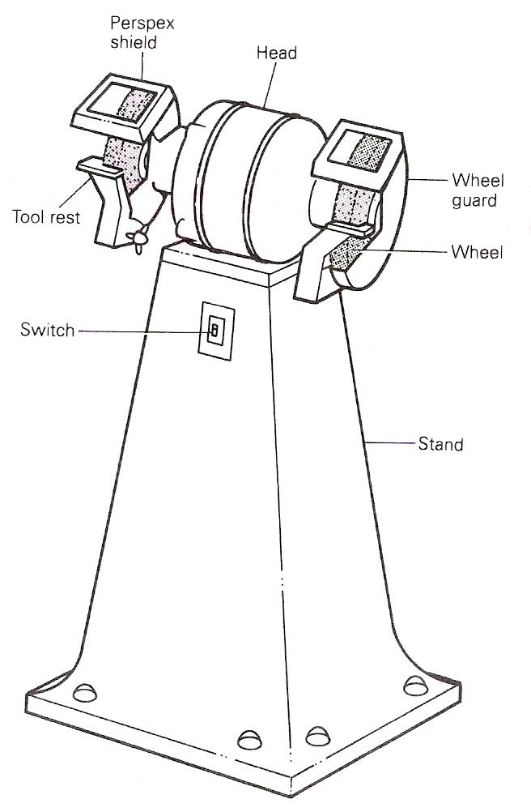
Figure 54 - Pedestal Grinder

The stand is made of heavy cast iron, which is bolted to a table or a specially designed stand. The pedestal type has a very heavy cast iron stand. The grinding head is the top of the machine housing the spindle, and is mounted on the stand in the pedestal type. The grinding head for the bench type is an integral part of a casing that houses the motor and the spindle.
The spindle carries the grinding wheels and is driven by means of a belt, which transmits the power from the driving motor. In the bench type the spindle is fixed directly to the motor. The grinding wheels that are attached to each end of the spindle do the cutting. Often, one wheel has a coarse grit and the other a fine grit, so that both rough and smooth surfaces can be produced on the same machine.
The tool rest in front of each wheel supports the tool being ground. It is adjustable. The gap between the rest and the wheel should always be small - about 2 mm to prevent the tool that is being ground from getting trapped. The wheel guards are fixed over the wheels to protect the user from the wheels. Some machines are fitted with adjustable glass or Perspex shields, which protect the user's eyes from the particles of the sparks.

The Grinding Wheel
The grinding wheel is classified as a cutting tool, because its action is considered to be a cutting one.
Grinding wheels consist of particles of abrasive material, such as aluminium oxide or silicon carbide, which are held together by a bonding agent known as a matrix.
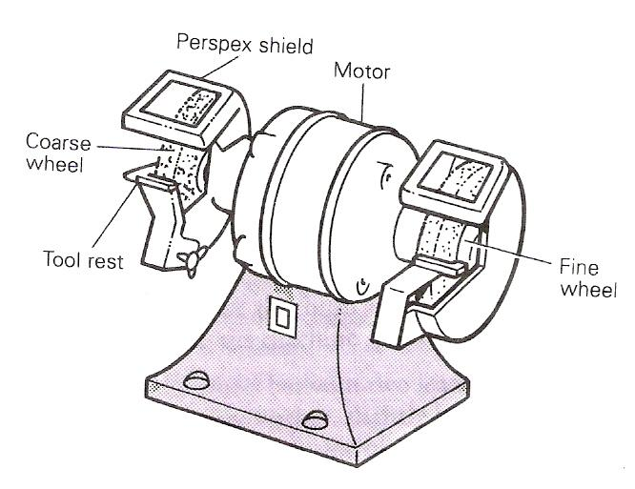
Figure 55 - Bench Grinder

The abrasive particles are known as grit, and they are graded by passing them through a sieve.
There are two types of abrasive: natural and artificial.
Emery (65 per cent pure) is one of the natural abrasives. It consists of crystals of aluminous oxides buried in a matrix of iron carbide. Another type is corundum (90 per cent pure), which consists of aluminium oxides containing varying amounts of other impurities. The commonly used artificial abrasives are silicon carbide and aluminium oxide. Silicon carbide is a chemical combination of carbon and silicon, and is used for materials of low grinding resistance. Aluminium oxide is a fused alumina, and is suitable for grinding steels.
Various materials and processes are used for the bonding matrix, but most wheels have vitrified bonds. These consist of different types of porcelain clays, baked hard. Other types of bonding ate:
- silicate bonds, in which sodium silicate (water glass) is used in addition to zinc oxide;
- rubber bonds, which consist of vulcanised rubber, and give the wheel some resilience;
- synthetic-resin bonds, in which Bakelite is used. The main application of these is in the so-called 'elastic' wheels.
The type of wheel used on the off-hand grinder has an abrasive of either silicon carbide or aluminium oxide with a vitrified bond. For grinding tools tipped with tungsten carbide or hard alloy steel, special silicon carbide wheels are used. These are green in colour and crumble fairly easily.
The general principle is that a soft wheel should be used for grinding hard materials, and vice versa.
The hardness of a wheel is called the grade. This does not refer to the hardness or size of the grit, but to the strength of the substance holding the grains together (the matrix). This means that a wheel may be termed soft yet be made from very hard abrasives. Different grades of wheel are produced by varying the amount and strength of the matrix.
The action of the grinding wheel is similar to a metal-cutting process. The many cutting edges of the wheel are created by the small grains of hard grits, which must always be kept sharp. It is therefore important that as the grinding proceeds and the grits become worn down they must be able to drop off and hence expose new cutting edges.
Figure 56 shows how the wheel is mounted. All grinding wheels have a metal bush through the centre, and the bore in the bush should be slightly larger in diameter than the machine spindle. When mounting:
- Grip the wheel between two lead flanges.
- Insert a paper washer, slightly larger in diameter than the flanges on each side of the wheel.
- Clamp the wheel between the flanges by means of a nut.
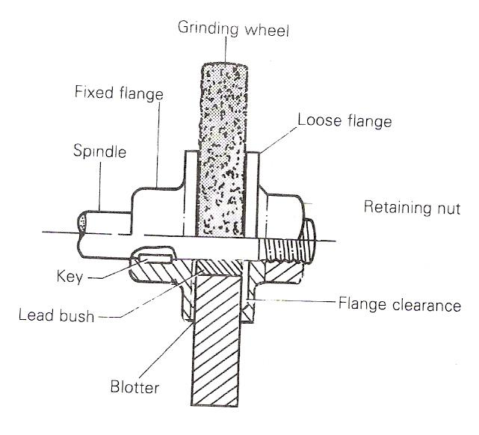
Figure 56 - Grinding Wheel Mounting
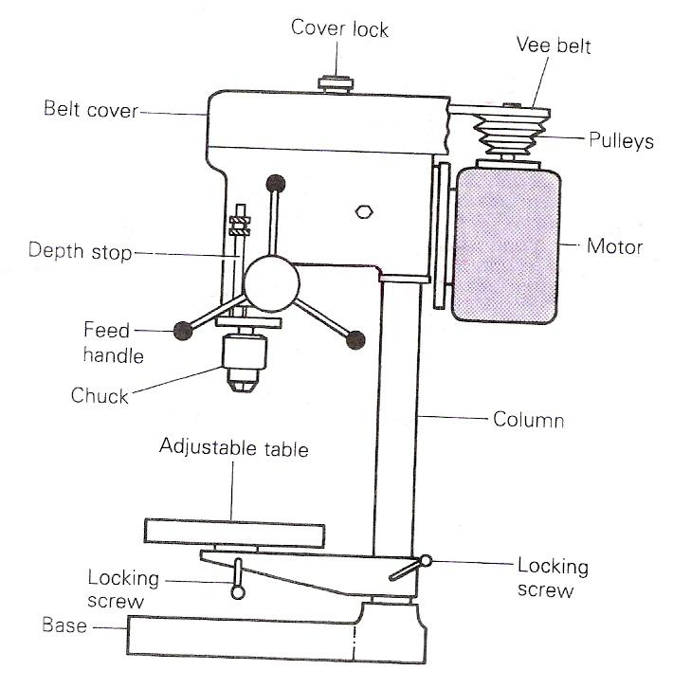
Figure 57 - Bench Drilling Machine

The flanges are recessed on their inner faces to ensure that pressure is exerted on the wheels as far from the centre as possible.
When grinding soft materials such as aluminium and brass, take care that the wheel has an open matrix. Wrong application will quickly load and glaze the wheel, and hence will retard its cutting action.
When a wheel becomes glazed, or worn unevenly, it has to be dressed to expose sharp clean cutting edges and true up the surface. Dressing can be done by holding either a diamond dresser or a star dressing wheel square to the revolving wheel until it is true.

The Drilling Machine
One of the common methods of joining metal components is by means of fitting. The process involves creating a hole or holes in one component and fitting the other component into it to form an assembly. The process of originating the hole is known as drilling and the machine used for the process is called a drilling machine, while the tool used is referred to as a drill.

Types of Drilling Machine
The popular drilling machines usually installed in school workshops are the bench drilling machine (Figure 57), and the pillar drilling machine (Figure 58). Both machines have common parts, except that the pillar drilling machine has a longer and more robust column (pillar) and is often fixed to the floor of the workshop. Figure 59 shows drilling in progress.
There is another type, known as a radial drilling machine, which has a radial arm onto which the drill head is fitted and along which it moves. This type is not usually found in school workshops.
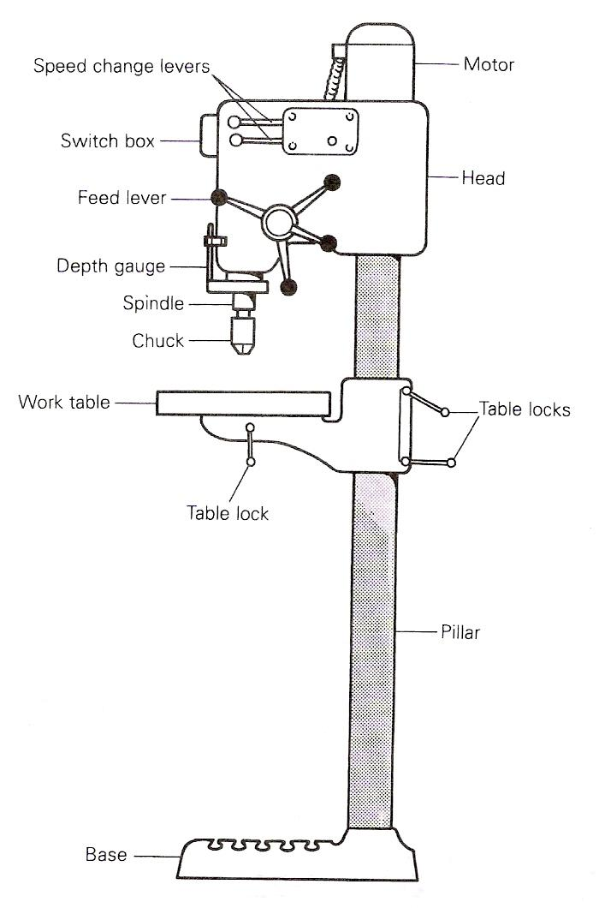
Figure 58 - Pillar Drilling Machine
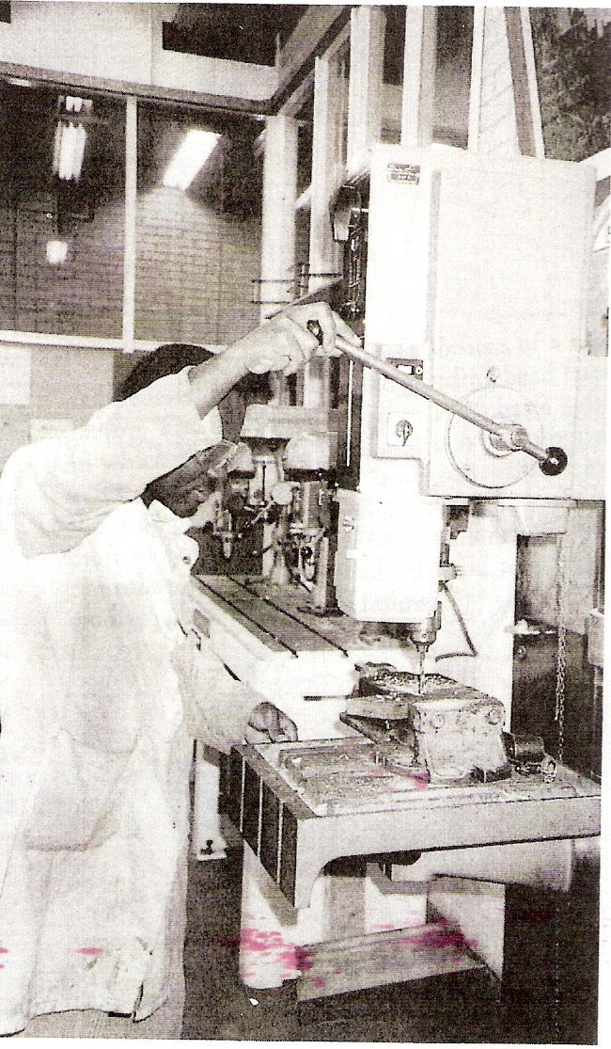
Figure 59 - Drilling Operation in Progress

Torque Wrench
From Wikipedia, the free encyclopedia
A torque wrench is a tool used to precisely set the force of a fastening such as a nut or bolt. It is usually in the form of a socket wrench with special internal mechanisms. A torque wrench is used where the tightness of screws and bolts is crucial. It allows the operator to measure the torque applied to the bolt so it can be matched to the specifications. This permits proper tension and loading of all parts. A torque wrench indirectly measures bolt tension. The technique suffers from inaccuracy due to inconsistent friction between the fastener and its mating hole. Measuring bolt tension (bolt stretch) is more accurate but most often torque is the only means of measurement possible.
Contents:
- Beam type
- Click type
- Differences between types
- See also

Beam Type
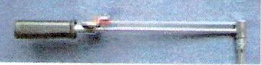
Figure 60 - Beam Type Torque Wrench
Beam type torque wrench. The indicator bar remains straight while the main shaft bends proportionally to the pressure applied at the handle.

The simplest form of torque wrench consists of a long lever arm between the handle and the wrench head, made of a material which will bend elastically a little under the applied torque. A second smaller bar carrying an indicator is connected back from the head in parallel to the lever arm. This second arm is under no strain at all, and remains straight. A calibrated scale is fitted to the handle, and the bending of the main lever causes the scale to move under the indicator. When the desired indicated torque is reached, the operator stops applying force. This type of wrench is simple but not very precise.
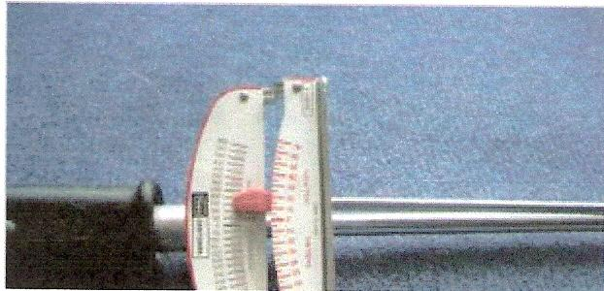
Figure 61 - Beam Type Torque Wrench Indicator

Click Type
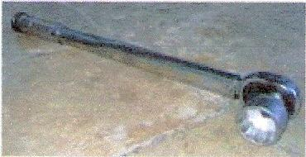
Figure 62 - Click Type Torque Wrench
Adjusted by turning the knurled handle.

A more sophisticated method of presetting torque is using a calibrated clutch mechanism. At the point where the desired torque is reached, the clutch slips, preventing over-tightening. The most common form uses a ball detent and spring, with the spring preloaded by an adjustable screw thread, calibrated in torque units. The ball detent transmits force until the preset torque is reached, at which point the force exerted by the spring is overcome and the ball "clicks" out of its socket. The advantage of this design is greater precision and a positive action at the set point. A number of variations of this design exist for different applications and different torque ranges. A modification of this design is used in some drills to prevent gouging the heads of screws while tightening them.

Differences between Types
Click type torque wrenches are more precise when properly calibrated - however the more complex mechanism can result in them losing calibration far quicker than the beam type, where there is little to malfunction. Beam type torque wrenches are impossible to use in situations where the scale cannot be read - and these situations are common in automotive applications. The scale on a beam type wrench is prone to parallax error, as a result of the large distance between indicator arm and scale. There is also the issue of increased user error with the beam type - the torque has to be read off each and every use.

For the click type, when not in use, the force acting on the spring should be removed by setting the scale to 20% of full scale in order to maintain the spring's strength. Never set a micrometer style torque wrench to zero as the internal mechanism requires a small amount of tension in order to prevent tool failure due to unwarranted tip block rotation. If a micrometer tool is has been stored with the setting above 20% the tool should be set to 50% of full scale.

Ironworker
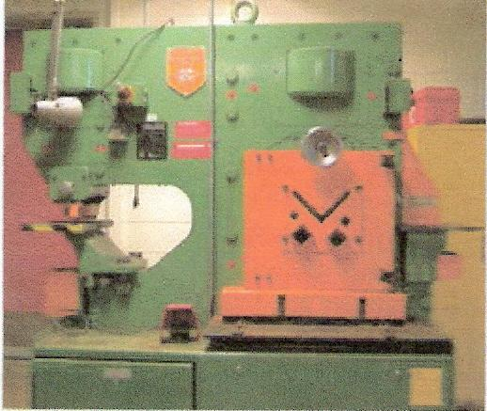
Figure 63 - Ironworker
This particular machine stands over 6 ft. (1.8 m) tall and can shear, notch and punch precision holes in plate steel up to 5/8 in. (15 mm) thick.

Ironworker also refers to someone who works in an ironworks, builds steel structures or makes products out of iron or steel. See International Association of Bridge, Structural, Ornamental and Reinforcing Iron Workers.

Ironworker was originally a brand name, but has since become the generic name, for a machine which can shear, notch, and punch holes in steel plate. This is accomplished with a powerful hydraulic system and a blade made of extremely hard and brittle (high carbon content) steel. Because of the enormous forces required to shear steel the machines must also be made of thick steel. It is common to see machines using steel over 1 inch (25 mm) thick. The hydraulic system is driven by an electric motor and three phase alternating current is chosen when possible. Hydraulic rams push down on a variety of hardened steel blades and dies to perform the shearing, punching, and notching action.

An Ironworker is an integral part of manufacturing facilities, and fabrication shops which involve working with steel. It is an indispensable asset to these operations due to the reduction in the amount of man hours and effort needed to cut or punch steel sections. They are rated in tons of force, and they range from 20 tons to 150 tons and higher, although the average machine is about 70 tons. They are easily re-tooled for various operations and can be operated by one person.

Structural Steel
Structural steel is a steel construction material, a profile, formed with a specific shape and certain standards of chemical composition and strength. Structural steel shape, size, composition, strength, storage, etc. is regulated in most industrialised countries.

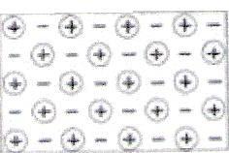

Steel is sometimes described as a sea of electrons. Protons are virtually surrounded by electrons. It is easy to see how the addition of heat first causes expansion and then softening, to the point of liquefaction. That is how steel is manufactured and that is how it acts as a structural element in a building fire.

Proper fireproofing mitigates this. Still, care must be taken to ensure that expansion of structural elements does not damage wall and floor assemblies required to have a fire-resistance rating. Of particular concern are any penetrants in a firewalls and ferrous cable trays in organic firestops.

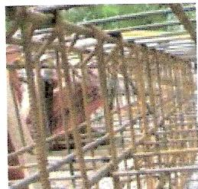

A tied rebar beam cage. This will be embedded inside of cast concrete to lend it strength. A bit of rust on the rebar actually increases the surface area and bonds well with concrete.

The high pH level of the concrete will minimise further rust damage to the rebar. In cases where too much concrete poison is dissolving the cement stone of the concrete, the rebar is then also no longer protected and rust can be seen to creep through cracks in faulty concrete.

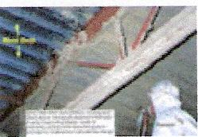
Metal deck and OWSJ (Open Web Steel Joist), receiving first coat of spray fireproofing plaster, made of polystyrene leavened gypsum, all subject to bounding on the basis of Underwriters Laboratories product certification listings. OWSJ require a great deal of spray fireproofing because they are not very massive and also because they are so open, that a lot of the sprayed plaster flies right past its constituent parts during the coating process.

Steel vs. Concrete
As raw material prices fluctuate, often so does building design. During times of lower steel prices, more steel and less concrete is used, and vice versa. Each set of vendors and users typically maintain national industry associations that advocate the use of its materials versus the other. However, both materials are really needed together. Concrete without steel re-enforcement is not structurally sound. Steel on its own, without solid concrete floors, is likewise not a preferred building method.

Fire Protection with Steel vs. Competition
As the critical temperature for steel is around 540°C (give or take, depending on whose country's test standards one reads at the time), and design basis fires reach this temperature within a few minutes, structural steel requires external insulation in order to prevent the steel from absorbing enough energy to reach this temperature. First, steel expands, when heated, and once enough energy has been absorbed, it softens and loses its structural integrity. This is easily prevented through the use of fireproofing. Likewise, although concrete structures on their own are able to achieve fire-resistance ratings, concrete is also subject to severe spalling, especially with elevated moisture inside the concrete at the time it becomes exposed to fire. There is also fireproofing available for concrete but this is typically not used in buildings. Instead, it is used in traffic tunnels and locations where a hydrocarbon fire is likely to break out. Thus, steel and concrete compete against one another not only on the basis of the price per unit of mass but also on the basis of the pricing for the fireproofing that must be added in order to satisfy the passive fire protection requirements that are mandated through building codes. Common fireproofing methods for structural steel include intumescent, endothermic and plaster coatings…

Structural Steels
Steels used for building construction in the US use standard alloys identified and specified by ASTM International. These steels have an alloy identification beginning with A and then two, three, or four numbers. The four-number AISI steel grades commonly used for mechanical engineering, machines, and vehicles are a completely different specification series.

Common Structural Shapes
All the shapes and sizes are typically listed in steel tables that vary from one country to another.
- I-beam (I-shaped cross-section)
- WF-Shape (Wide Flange Steel Materials and Rolling Processes (U.S.)
- H-Shape (another name for WF-Shape. The flange is equal to, or greater than, the web) Z-Shape (half a flange in opposite directions)
- Hollow structural section (hollow square or rectangular cross-section)
- Pipe (hollow round cross-section)
- Angle (L-shaped cross-section)
- Channel (C-shaped cross-section)
- Tee (T -shaped cross-section)
- Railway rail (asymmetrical I-beam)
- Bar, a piece of metal, rectangular cross sectioned (flat) and long, but not so wide so as to be called a sheet.
- Rod, a round or square and long piece of metal or wood, also rebar.
- Plate, sheet metal thicker than 6 mm or 1/4 in.

Standard Structural Steels
The standard commonly used structural steels are:

Carbon Steels
- A36 - structural shapes and plate
- A53 - structural pipe and tubing
- A500 - structural pipe and tubing
- A501 - structural pipe and tubing
- A529 - structural shapes and plates

High Strength Low Alloy Steels
- A441 - structural shapes and plates
- A572 - structural shapes and plates
- A618 - structural pipe and tubing

Corrosion Resistant High Strength Low Alloy Steels
- A242 - structural shapes and plates
- A588 aka Cor-ten - structural shapes and plates

Quenched and Tempered Alloy Steels
- A514 - structural shapes and plates
- A517 - boilers and pressure vessels

Using Machines
You need to understand how to use machines in the workshop before you handle them in practice. There are specific precautions to observe when you are using the following machines.

Drilling machines
Hold the work properly in a vice, and bolt the vice when necessary to prevent it from 'spinning round'. Use all protective guards on the machine. Never be tempted to hold small workpieces in your fingers.

Centre lathe
Secure work firmly in the chuck and never leave the key in the chuck before starting the machine. It is dangerous to remove the swarf once the machine is in motion. Make use of the safety devices attached.

Shaping machine
Secure the work and the vice firmly. Remember that chips fly out at the end of every action, and they can cause eye injury.

Milling machine
Never make any adjustment while the machine is running. Do not apply coolant to the work with a brush when the cutter is revolving. Keep your hands away from the cutter when it is in motion. Milling chips are sharp; do not clear them away with your hands.

Grinding machine
Use the eye guard and goggles to protect your eyes when grinding. You can hold small work in a hand vice to prevent it from being dragged into the gap between the wheel and the tool rest.

Lifting Objects
You will regularly have to lift various objects - sometimes quite heavy ones. The lifting position should be as shown in Figure 64 to prevent injury to your spine and back muscles. Never go near or beneath suspended loads; there is always the chance that they might fall and cause an accident.

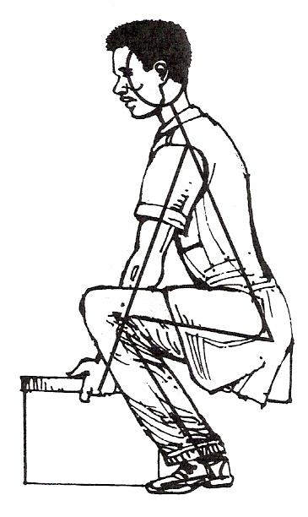
Figure 64 - Correct Posture for Lifting Objects

Self Assessment
Questions on Background Notes – Module 4.Unit 1

1. In relation to bolts used in Structural Steel, what is a Black Bolt?

2. Give an example of where you might use a Turned Barrel Bolt.

- Where would you find a Taper Washer?

4. With the aid of diagrams show where the Back Marks and Cross Centres would
be located on a steel section.

5. In relation to Lifting Techniques, list three key points when performing a
lift.

Answers to Questions 1-5. Module 2.Unit 6
1.

Black Bolt:

Usually hot forged and roll or machine threaded. Used mainly as
a service bolt, for temporarily bolting fabrications together prior to
riveting and tack bolting. They may also be used as permanent
bolts for lightly stressed fabrications. They are the cheapest form of
bolt available.

Clearance: The diameter of the bolt hole is usually 1.5 mm larger
Than the diameter of the bolt shank.

2.

Turned Barrel Bolt:

These bolts are used when the highest of accuracy is required
and subassembly of fabrications prior to checking for alignment
and fabrications subject to heavy loads.

3.

Taper Washer:

Is found on a turned barrel bolt.
Figure 1:

4.

Figure 2: Black Marks.

4. Continued

Figure 3: Cross Centre.

5.

Lifting Techniques:

- Check the Environment and Load.
- Broad Stance.
- Flat Back.
- Bend Knees – Lower your body down.
- Head Down.
- Firm Grip.
- Raise Head and stand up.
- Pull load in close to body.

Index

A
Appearance, Strength and Safety in Fabricated Structural Members, 75
Appearance, 75
Strength, 75
Web Stiffeners, 76
Application of Pythagoras Theorem, 12
B
Black Marks and Cross Centres, 32
Bolted Joint, 79
External Links, 84
Failure Modes, 82
Locking Mechanisms, 83
Property Class, 82
References, 84
See Also, 84
Setting the Torque, 81
Theory, 80
Types of Bolts, 83
C
Common Structure Sections, 13
D
Drifts, 34
E
Engineering Adhesives
Designing for Adhesives, 51
Engineering Applications, 52
Instant Adhesives, 54
The Bond Line, 52
F
Fasteners and Locking Devices, 23
Fasteners used in the Industry, 49
Engineering Adhesives, 50
Structural Applications, 49
H
Heat
Engineering Science, 48
L
Lifting and Turning Technology, 55
Base Movement (8 Key Points), 55
Clothing, 61
Common Lifts, 58
European Legislation, 64
Forces and Levers, 59
Lifting Techniques, 55
Manual Handling of Loads Regulation 27 - 28, 62
Material Removal, 65
Lifting Objects, 99
Lifting Techniques
Kinetic Principles, 55
Locking and Retaining Devices, 14
Locking by Adhesives, 22
Locking Plates, 19
Shakeproof Washers, 16
Simmond's Locknut, 15
Slotted Nuts and Castle Nuts, 15
Split Cotter Pins, 22
Spring Washers, 16
Tab Washers, 18
Taper Pins and Parallel Pins, 20
Wire Locking, 17
M
Machine Tools, 85
Beam Type, 92
Click Type, 93
Differences between Types, 93
Introduction, 85
Ironworker, 94
The Drilling Machine, 89
The Off-Hand Grinding Machine, 85
Torque Wrench, 92
Material Removal
Clamping of Work, 41
Moment of a Force, 42
Movement in the Workshop, 65
Movement of Materials under Adverse Conditions, 65
Movement on Site, 65
Principle of Moments, 40, 43
The Moment of a Force, 44
Use of Spanners, 41
Mechanical Properties of Materials
Behaviour of Materials under the Application of a Force, 39
N
Nature of Force, 35
Basic Strength of Materials, 46
Heat, 47
Material Removal, 40
Mechanical Properties of Materials, 39
Simple Atomic Structure, 45
Units of Length, 37
P
Pitch Circle Diameter (P.C.D.), 33
S
Self Assessment, 100
Standard Structural Steels
Carbon Steels, 97
Corrosion Resistant High Strength Low Alloy Steels, 97
High Strength Low Alloy Steels, 97
Quenched and Tempered Alloy Steels, 97
Structural Engineering, 72
Structural Steel, 95
Common Structural Shapes, 97
Fire Protection with Steel vs. Competition, 96
Standard Structural Steels, 97
Steel vs. Concrete, 96
Structural steels, 96
T
The Drilling Machine
Types of Drilling Machine, 90
The Off-Hand Grinding Machine
The Grinding Wheel, 87
Types of Off-Hand Grinder, 85
Theory
Thread Strength, 81
Types of Bolt, 24
Application and Advantages, 27
Black Bolt, 24
Close Tolerance Bolt, 24
Turned Barrel Bolt, 24
Washers, 28
U
Units of Length
Measurement of Length, 37
Using Machines, 98
W
Washers
Flat Type, 30
General, 28
Load Indicating Type "Coronet", 29
Spring Types, 30
Taper, 28

